Escrick Heritage

Newsletter 2
June 2018

Welcome to our second volunteer newsletter! The newsletter is produced every month to keep you up to date with everything that is happening on the project and to celebrate our progress.

Community Archive

A huge thank you to everyone who volunteered to help record and scan all the memories, photographs and documentation at our first ‘Sharing Memories’ day. We had a wonderful day thanks to the steady stream of people who were kind enough to share their memories of Escrick, so thank you to them as well!

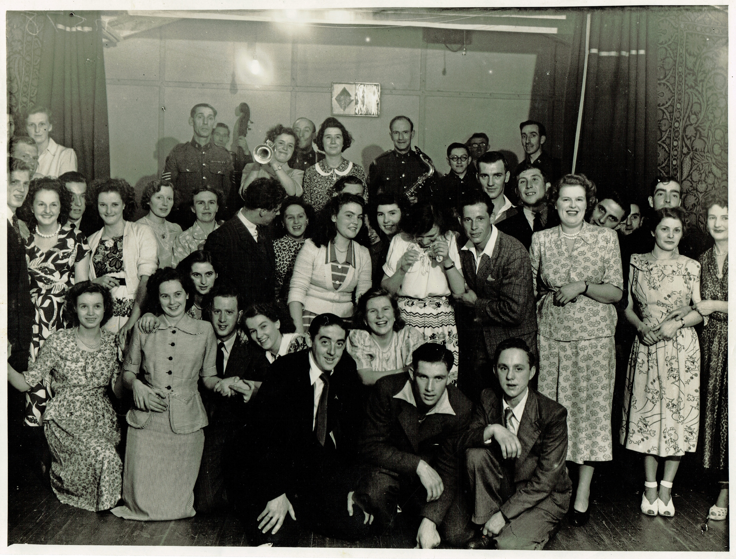
Dance Party, The Hut 1949 cc Irene Burton
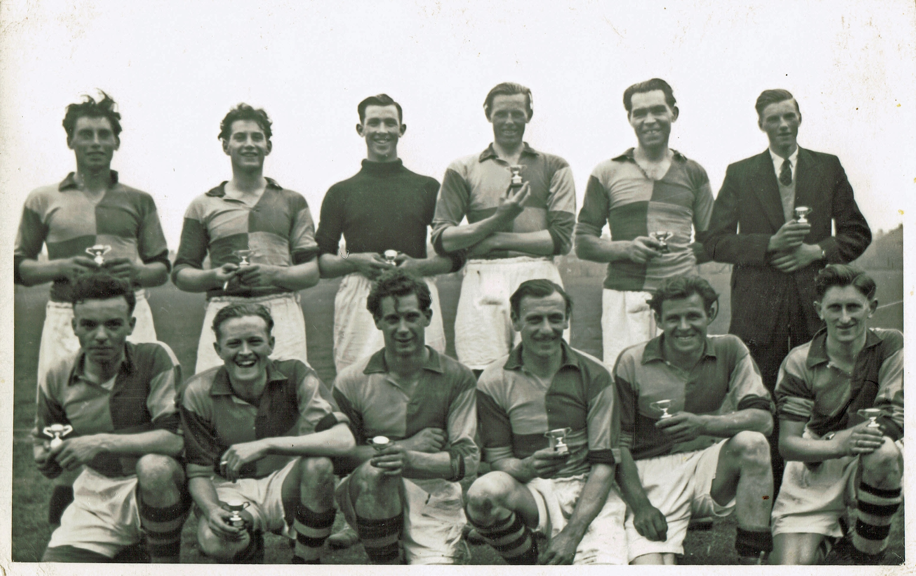
Local football team late 1940’s/early 1950’s cc Irene Burton

Our next ‘Sharing Memories’ day will be July 4th at the Escrick teashop 2.00-4.00pm. If you would like to assist with the scanning and documentation please let us know or if you have any documents or photographs relating to the history of the Parish that you are happy to share please bring them along so that we can scan them for the archive.

Media Vision

Chris has been working hard on our logo and we are now able to give a sneak preview of the black and white version.

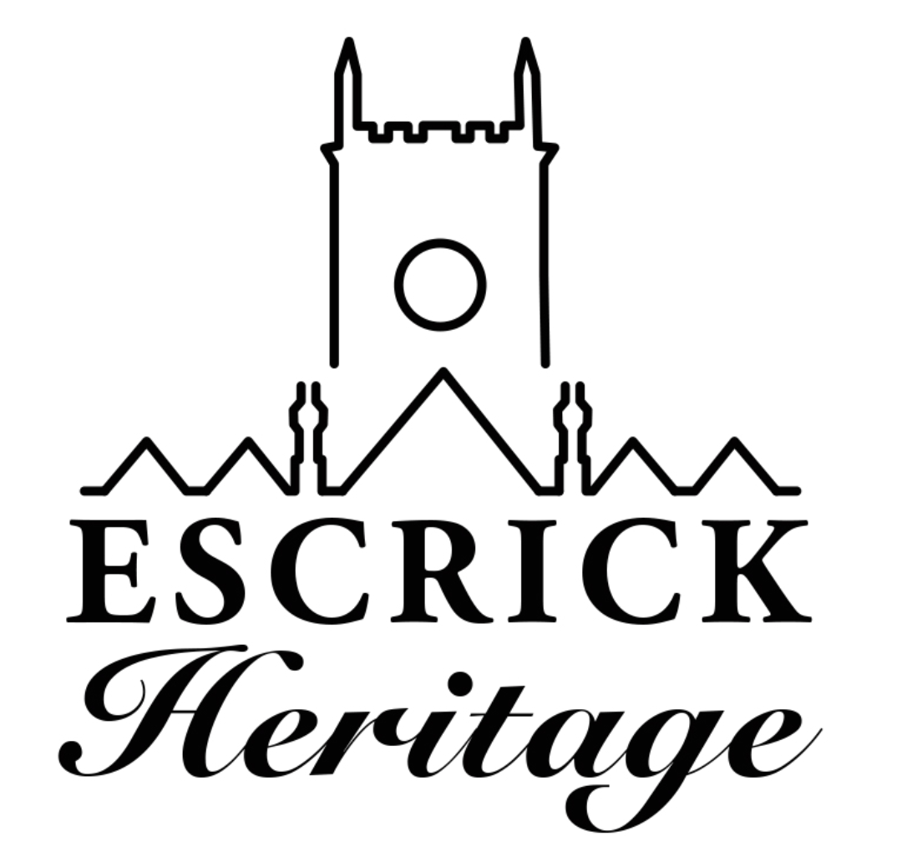
Chris was given the brief to represent the church, village and estate within the logo and we think the use of the distinctive estate houses roofline coupled with the church tower does just that. We hope you like it as much as we do.

Pre-School

We’re really looking forward to our first visit later this month from Escrick Pre-School who will be joining us to explore the church with Hoot the owl and his friends!

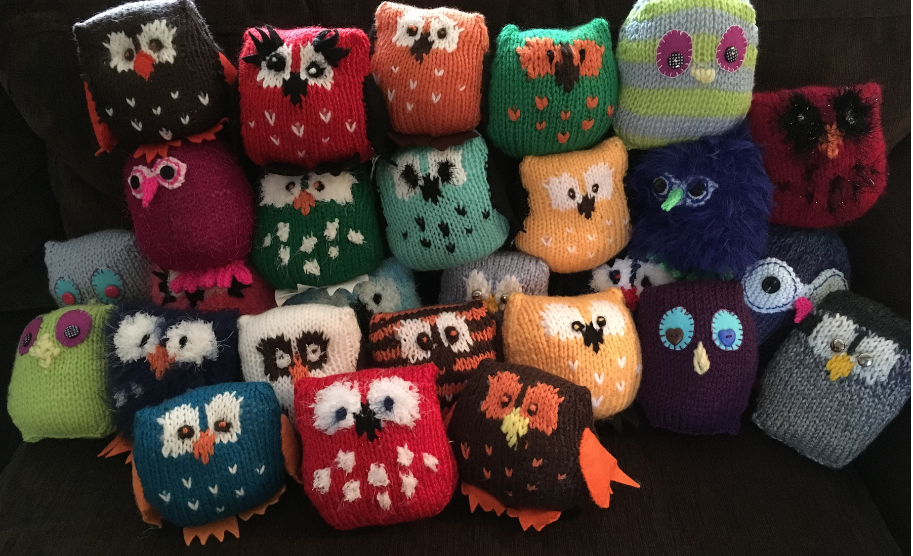
Just some of the owls that volunteers have created for the children’s trail

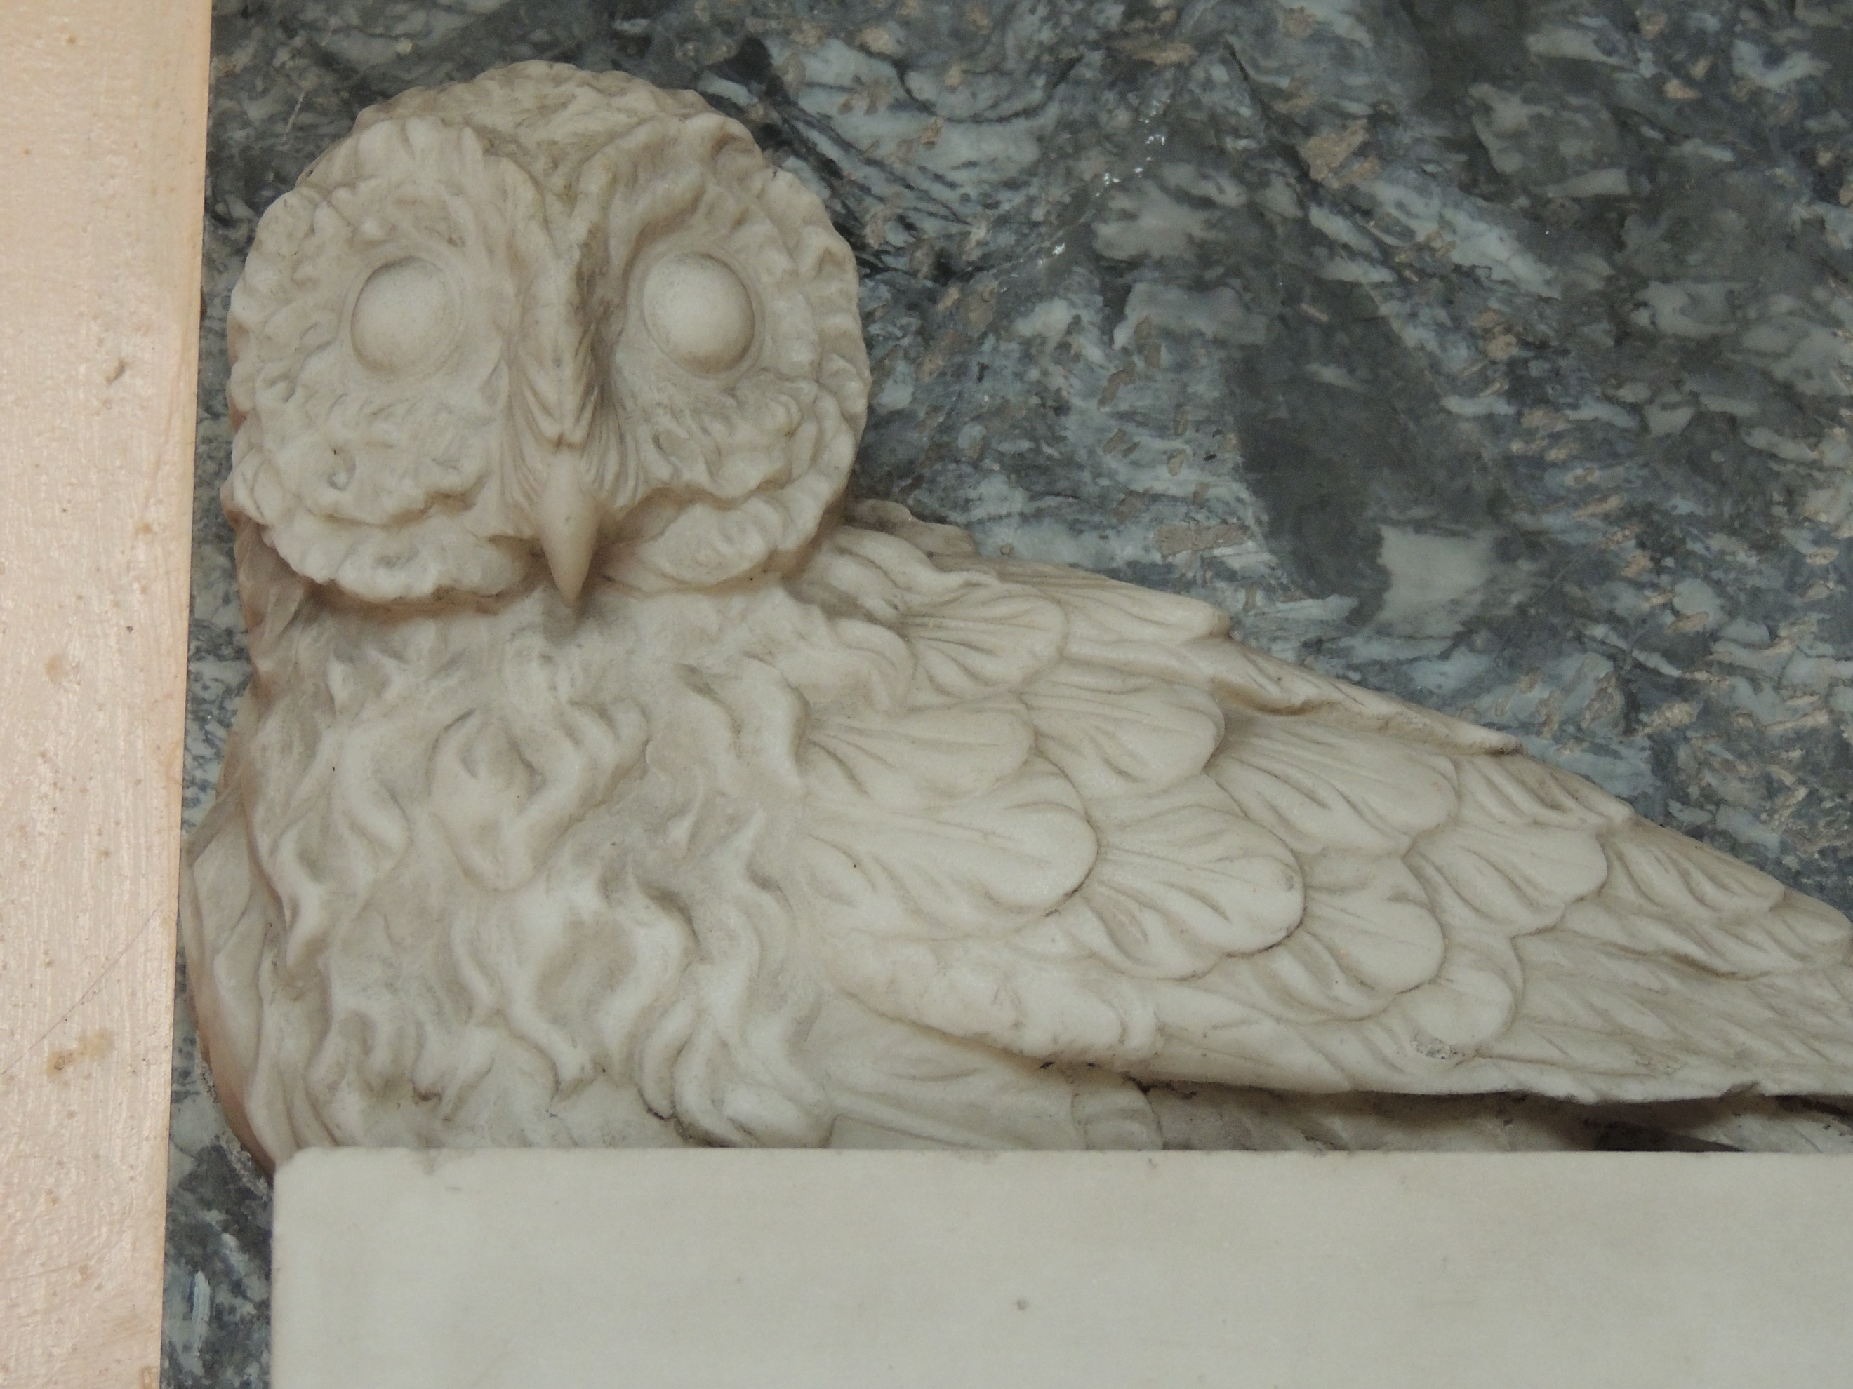
The original ‘hoot the owl’ who can be found hiding in the baptistry

Young Volunteers

Volunteers from Year 5 and 6 at Escrick Primary School have been helping our heritage officer to design the children’s trail and the children’s interactive game. The enthusiasm for the project and the fantastically creative ideas have really informed the work and we look forward to our next visit when the children will be creating names for our new games herald.

Dementia Friends

As part of the project we will be opening a memories café next year which will ensure a welcoming space for people with dementia and their carers. We want to extend this welcome across everything that we do and our first step towards this is to host a Dementia Friends Information Session in the Church. This will be taking place on Monday 25th June 6.30-8.00. The session will be open to everyone in the Parish whether they are directly involved with the project or not.

Heritage Open Day Volunteers

This will be our last heritage event in the church before the building work starts and we’re looking for volunteers to plan a memorable afternoon. If you would like to help plan and/or deliver this event please do get in touch. We will be having our first planning meeting on Monday 16th July 7.00-8.00 at the church. Please pop along and share your ideas. www.heritageopendays.org.uk

Research Volunteers

We are looking for someone to start our research about Escrick in WWII. The research will be used to create a short community panel. If you may be interested please contact Michala for more details.

Volunteer Information

In between newsletters you’ll be able to find information on the volunteer’s notice board in the North Aisle and copies of all our policies can be found in the blue folder in the vestry.

Michala, our Heritage Engagement Officer will also be in church on the following dates if you have any research you would like to share with her or if you have any questions about your volunteering role. The kettle will be on so please pop in and say hello.
Tuesday 26th June 10.00-11.30am
Tuesday 17th July 10.00-12.00pm

Events

Milk First or Tea First?

Join us for a fascinating talk by author Meryl White on the history and etiquette of afternoon tea and then put it all into practice with a sumptuous vintage afternoon tea.

We are creating a ‘memory table’ for this event so if you have any old recipe books, photographs or items linking to the theme of afternoon tea please bring them along to share.

July 1st 2.00-4.00pm tickets £7.50 available at the village teashop, www.eventbrite.co.uk or from Caroline 07774461026 escrickchurch@gmail.com

Dates for Your Diary

16 June Interpretation Training 9.30-1.00

25 June Dementia Friends Training 6.30-8.00

26 June Volunteer Drop-in 10.00-11.30

1 July Afternoon Tea and Talk 2.00-4.00

16 July Heritage Open Day meeting 6.30-7.30

17 July Volunteer Drop-in 10.00-12.00

8 September Heritage Open Day 11.00-4.00

If you would like more information about anything in the Newsletter or would like to volunteer please contact, Michala Pearson escrickheritage@gmail.com or Caroline Wandless escrickchurch@gmail.com

If you no longer wish to receive this newsletter please contact escrickheritage@gmail.com

