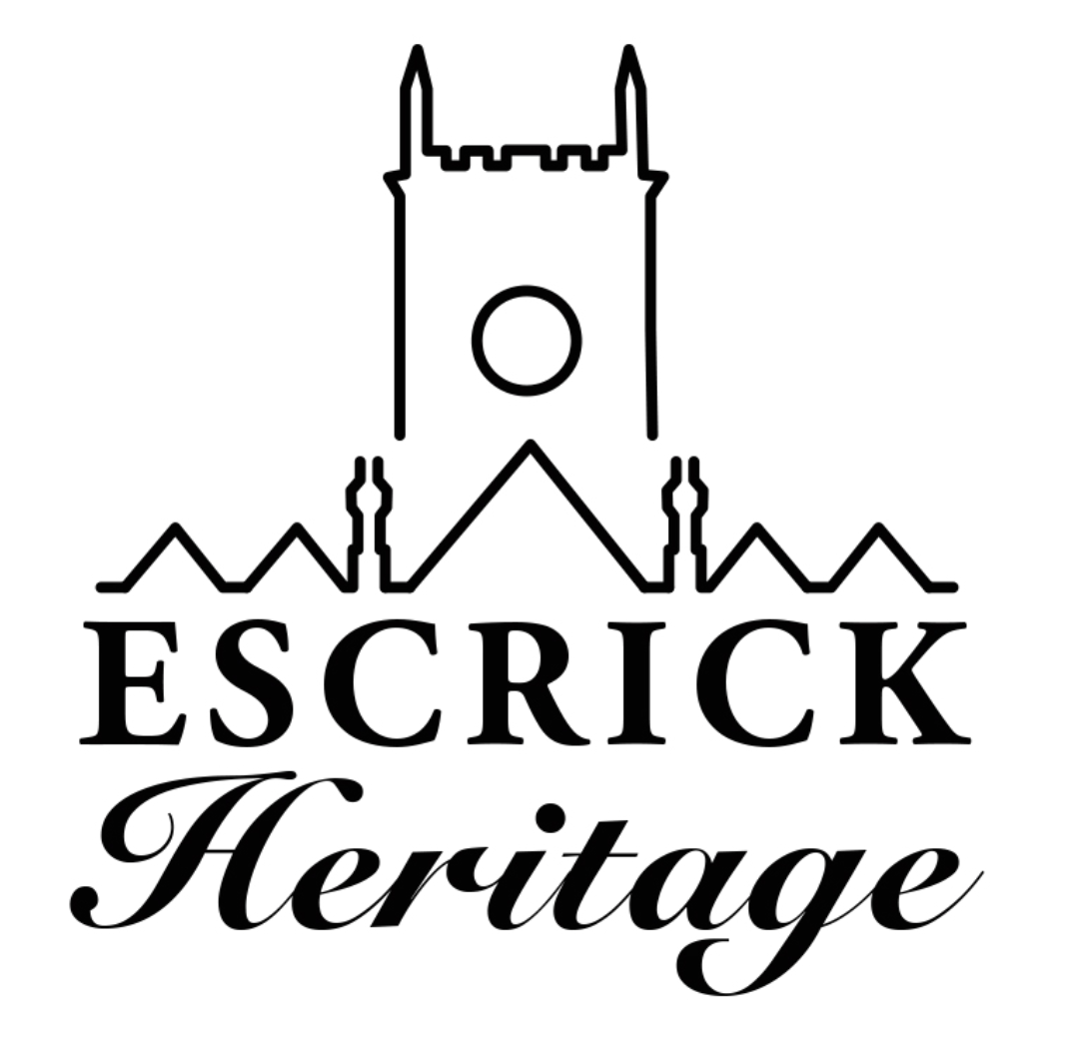
September Newsletter
Issue 4

Welcome to our fourth volunteer newsletter! The newsletter is produced every month to keep you up to date with the project and to celebrate our progress.

Community Archive

We have continued to build the archive and now have over 500 images and documents scanned and recorded. We met with Laura from York Archives to discuss the best ways to record and store our archive. She was very happy with our cataloguing system. Now all we have to do is transfer the written notes into a searchable data base! This will be a labour intensive job, so thank you to those who have volunteered to help. The first images will be available to view in November via our new website.

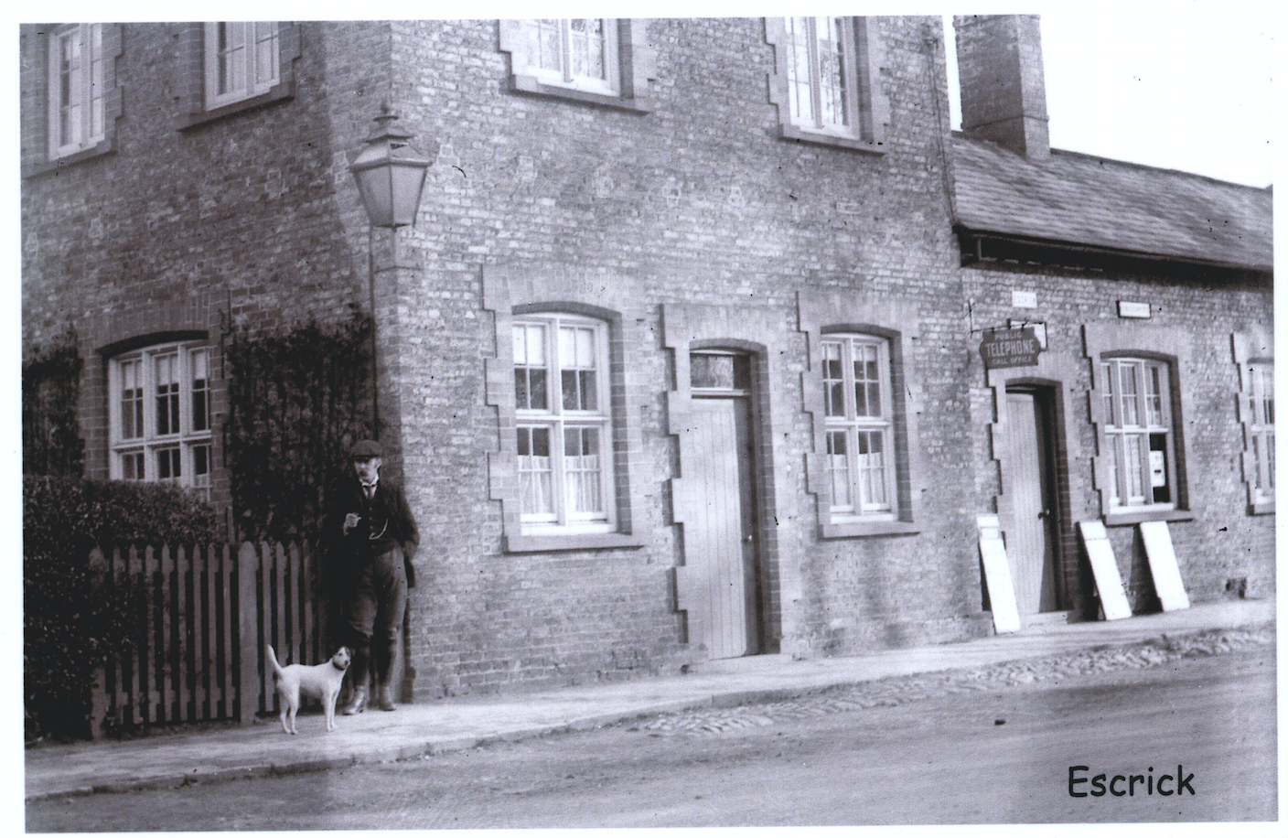
Postcard shared with the community archive by G Shearsmith

Media Vision

A huge thank you to everyone that worked on the community panels which have now been sent to Chris for the design stage. We are hoping that they will be in-situ by the end of October.

Work is continuing on the website and the project team have been busy creating the final text for Chris to incorporate into the design. We will be officially launching the website at our Heritage meeting on 7th November at The Club.

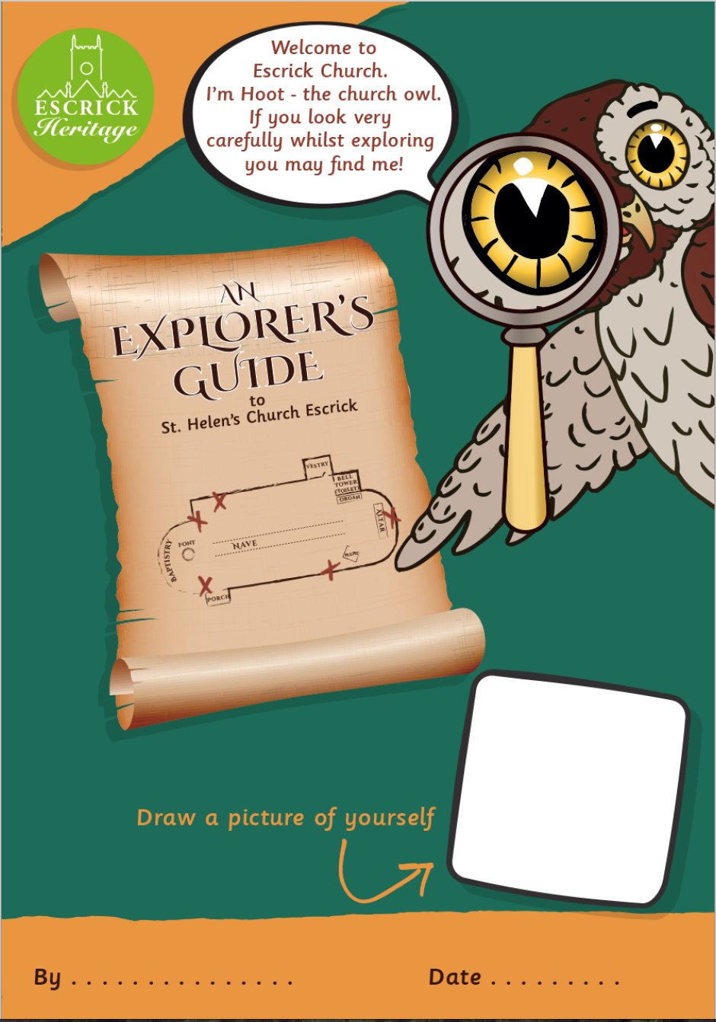

Children’s trail pre-view with our mascot Hoot the Owl

Escrick Primary School

Year 6 have started their research into the history of the school. Our Heritage Engagement Officer delivered a research and an interpretation workshop to prepare pupils for creating their own exhibition.

If anyone has any old photographs, certificates, attendance medals or memories of school days in Escrick we would love to share them with the children. Please contact escrickheritage@gmail.com

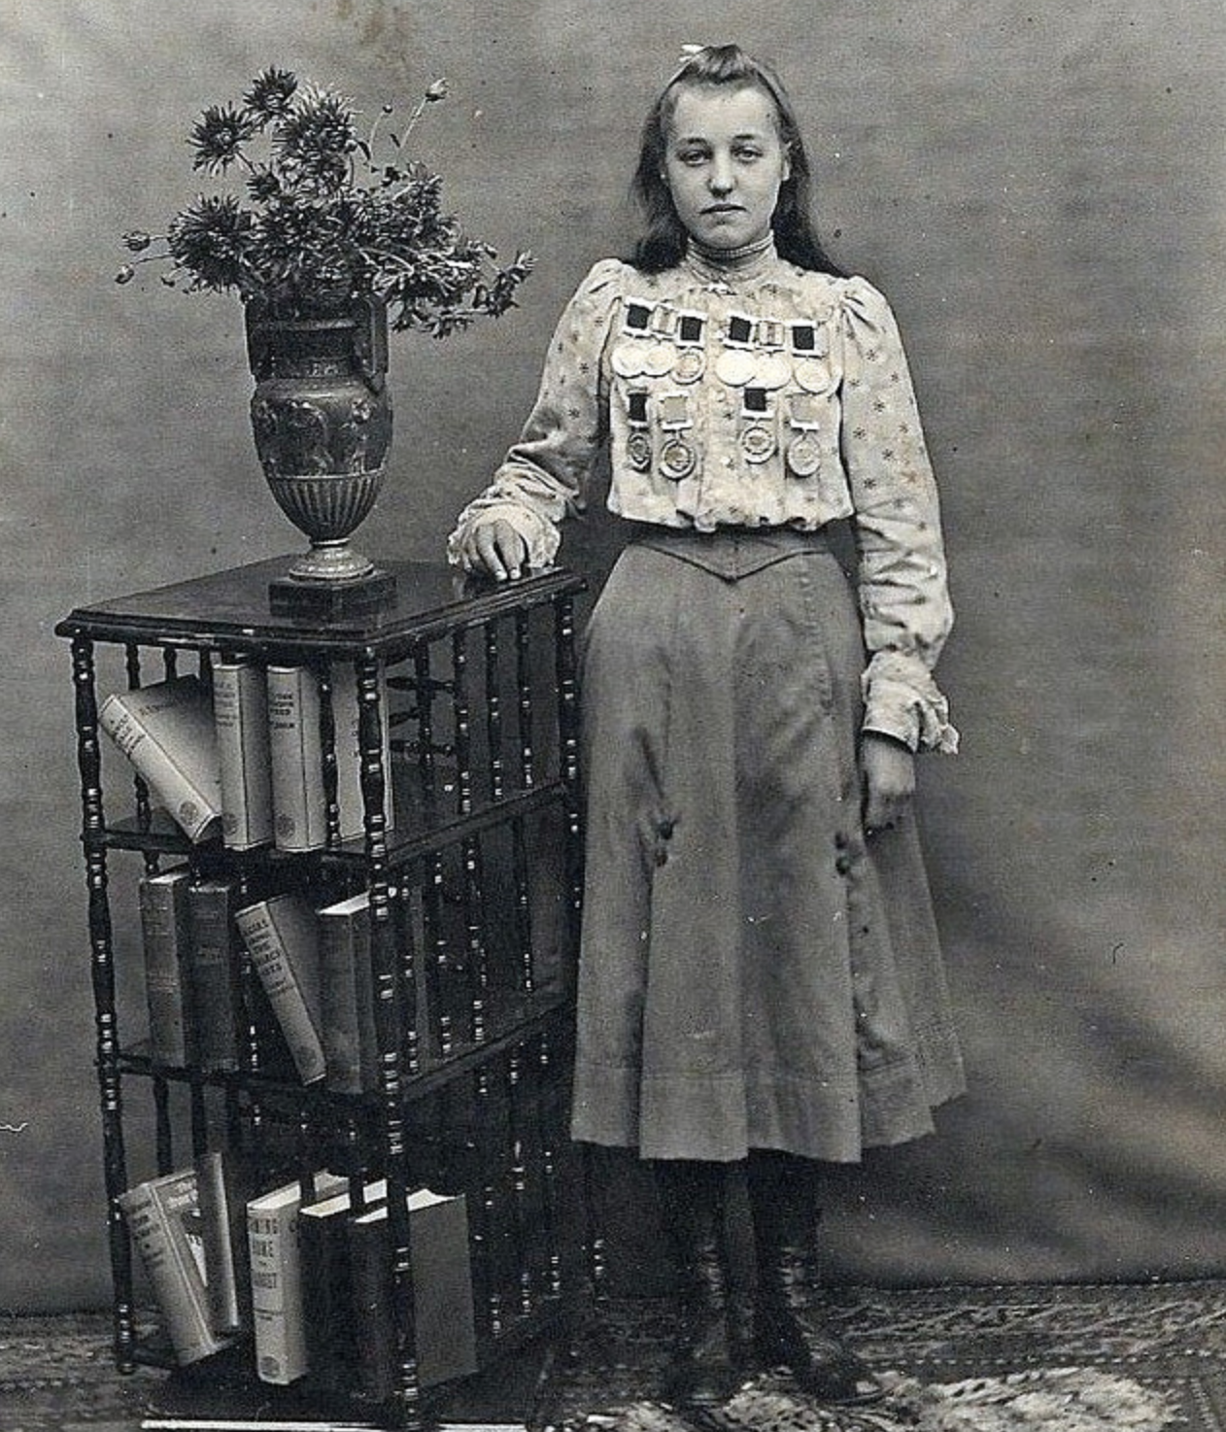

Kitty Colley with school attendance medals c1906 shared with the community archive by Brad Colley

Oral History Project

Volunteers have now completed four of our eight oral histories for the project. Although we are committed to completing eight interviews as part of the HLF project such has been the response and enjoyment from both interviewers and interviewees, not to mention information gathered, we have decided to continue collecting and recording the stories of local people and will add them over time to our archive.

Michelle from the Oral History Society will be delivering our final training day in October which will focus on making the oral histories accessible and useable now and into the future.

Heritage Open Day

We had a fantastic time at our Heritage Open Day with over 80 visitors. Our volunteers were kept extremely busy providing refreshments, creating craft activities, judging Lego towers and giving tours of the church and tower. Thank you to everyone who contributed to making it such a successful day.

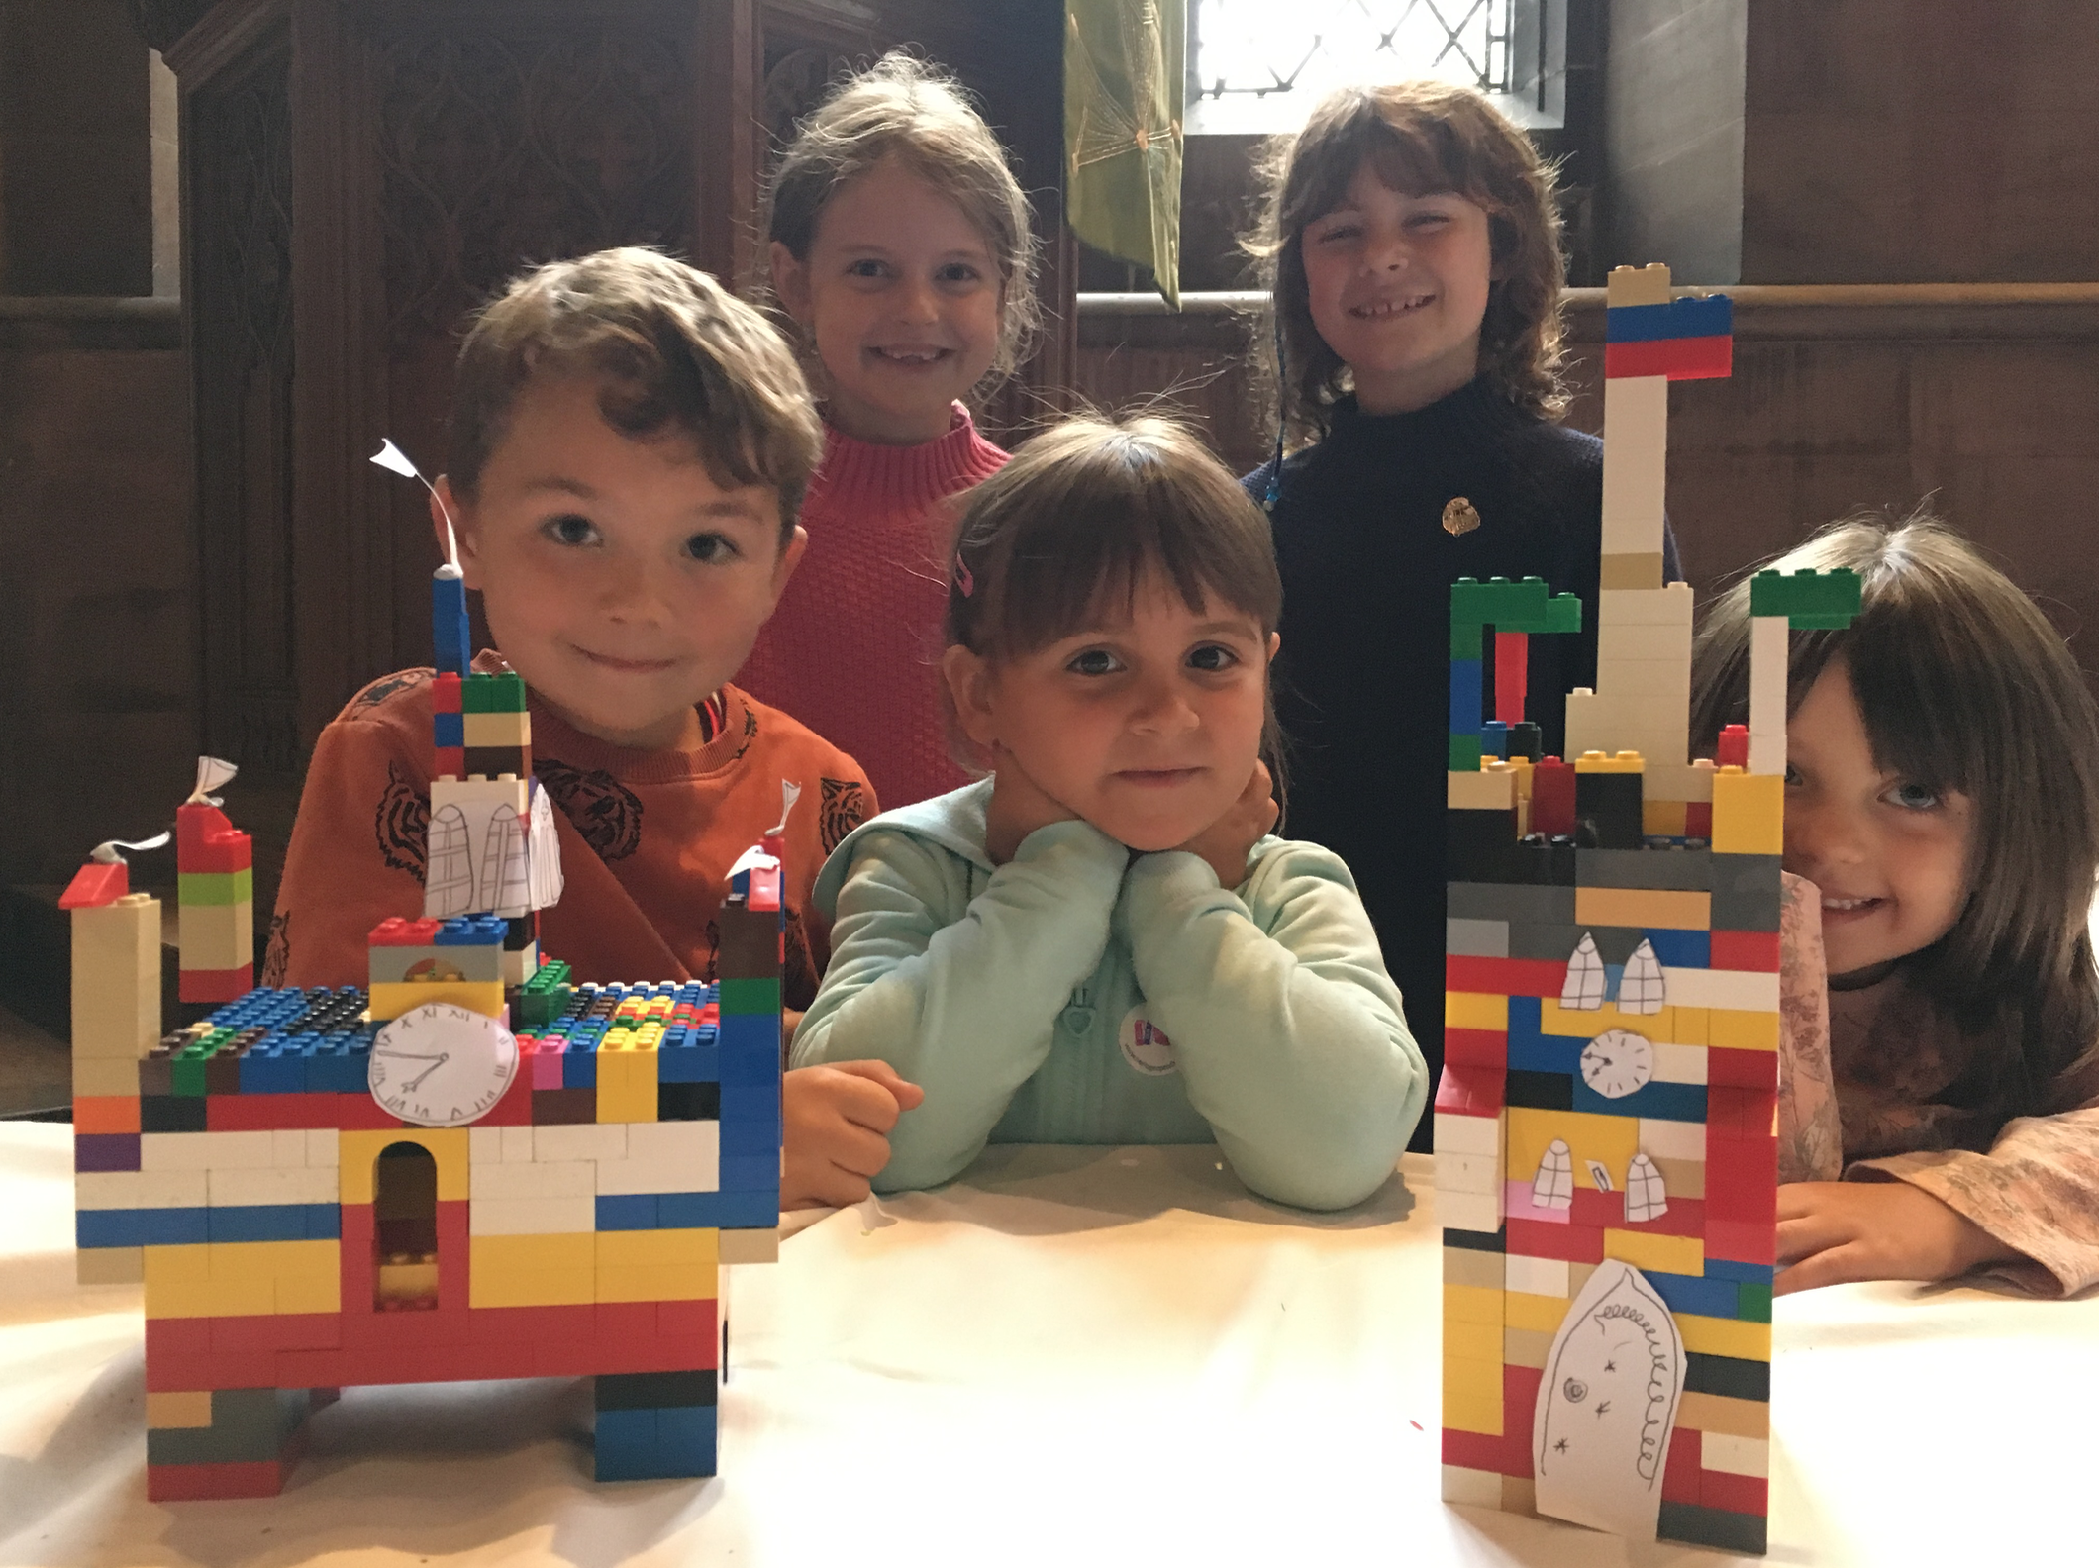
Lego Tower builders as featured in the Selby Times!

Church building Works

The Contractors moved in to Church as planned on 10th September and immediately started the preparation work. They have boxed in the font, Lady Caroline, Legless and the piano and the organ has been professionally protected against dust and dirt. The first of the internal scaffolding is in place and the asbestos removal contractors are on site. They have all their blue protective tents in place over the floor access hatches and are negotiating through the floor voids, some of which are less that 50cm high! We are pleased to say that all is going to plan.

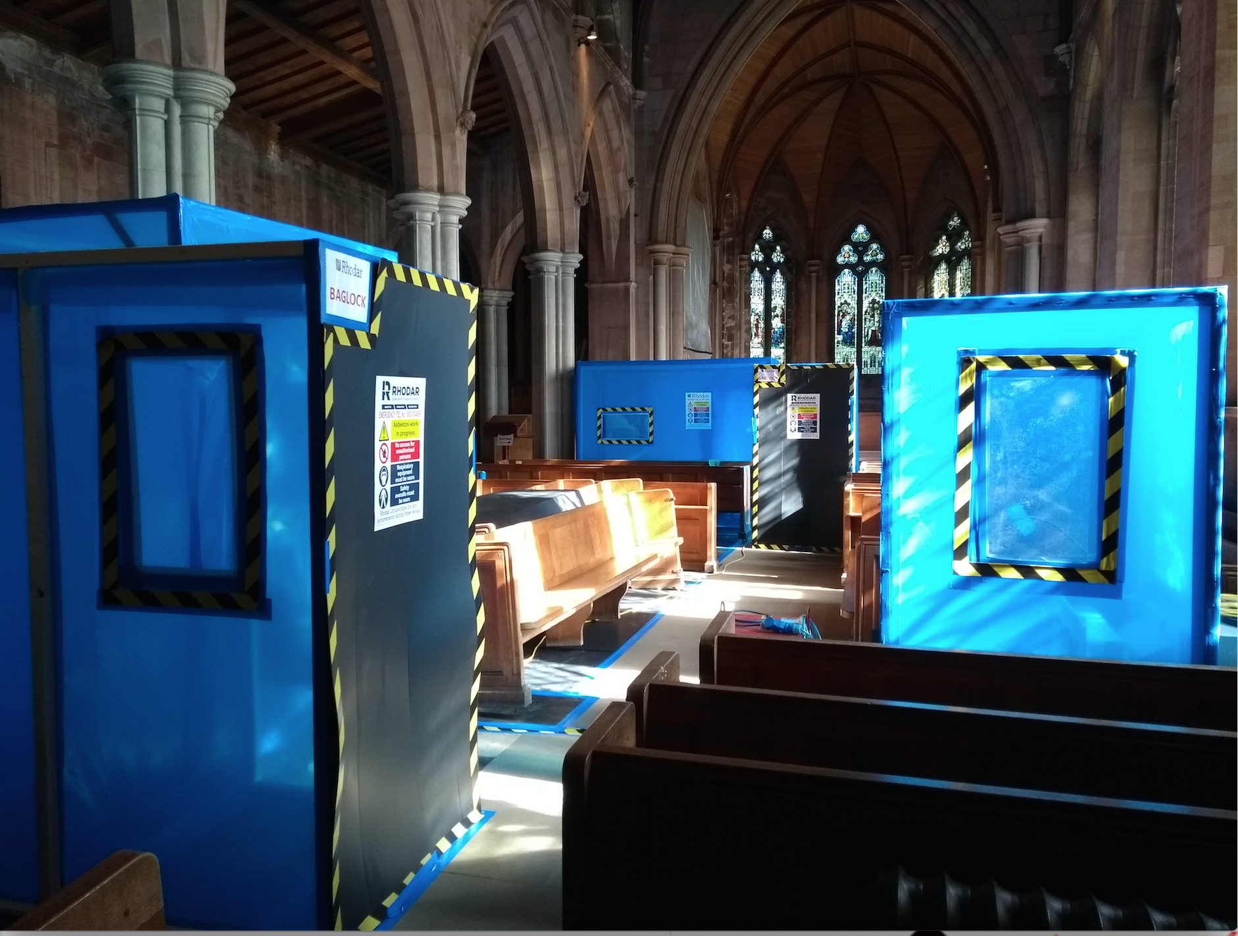
Asbestos removal tents in Church

Escrick Heritage Monthly Meetings

Our first heritage meeting was a well-attended and very social occasion! Caroline gave us an excellent overview of the building and conservation work and we had a lively discussion about our permanent exhibition and the stories we think we should be telling our visitors. Our HEO will be looking at all the ideas and feeding back on progress at the next meeting on October 3rd 7.00-8.30 at The Club.

As well as giving you the opportunity to catch up with all the project news we will also be discussing ideas for the guide book.

Dates for Your Diary

3rd October Heritage meeting, The Club
7-8.30pm
7th November Heritage meeting, The Club
7-8.30pm
6th April Family History Workshop

If you would like more information about anything in the Newsletter or would like to volunteer please contact, Michala Pearson escrickheritage@gmail.com or Caroline Wandless escrickchurch@gmail.com

If you no longer wish to receive this newsletter please contact escrickheritage@gmail.com

