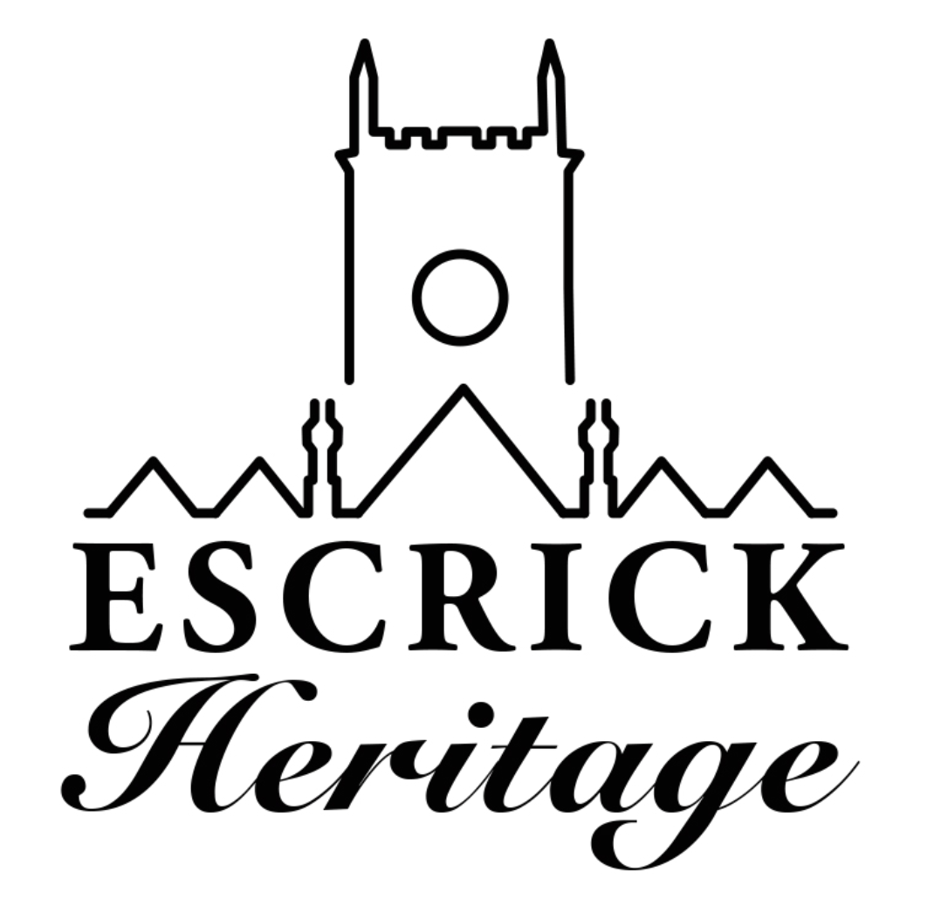
October Newsletter
Issue 5

Welcome to our fifth volunteer newsletter! The newsletter is produced every month to keep you up to date with the project and to celebrate our progress.

Media Vision

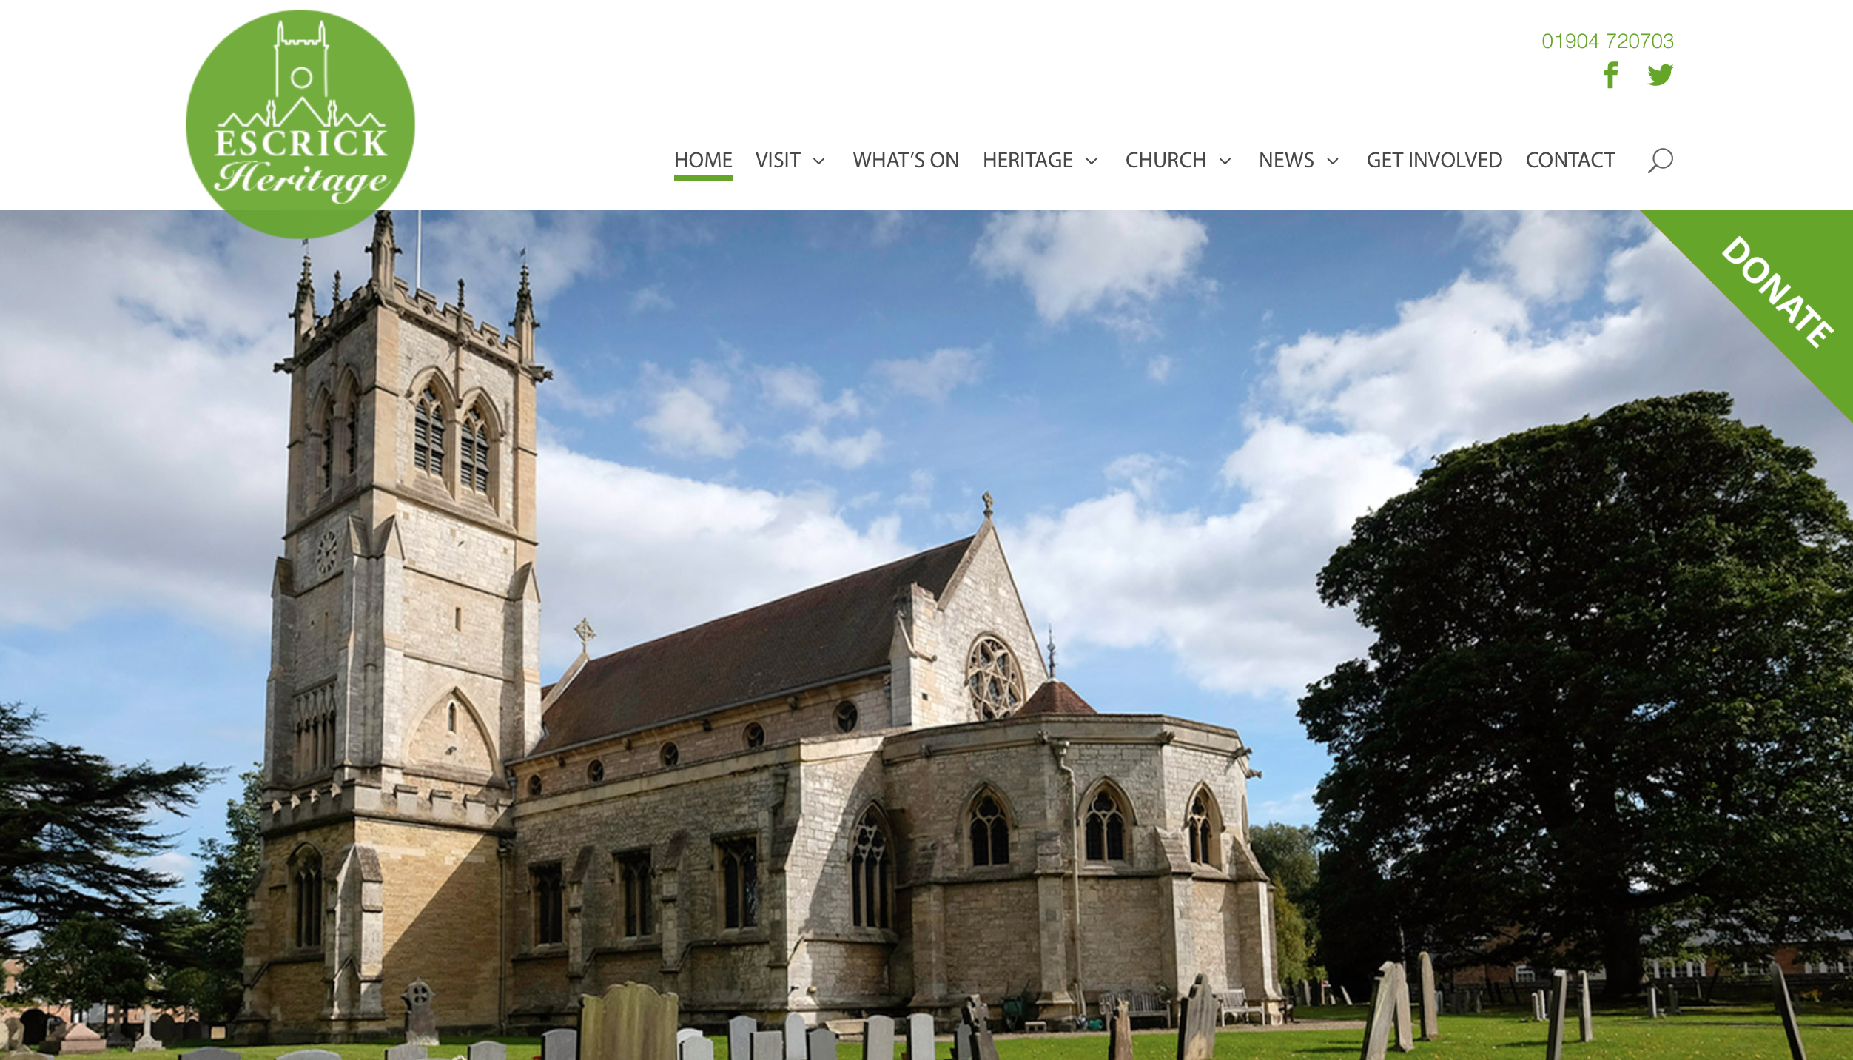

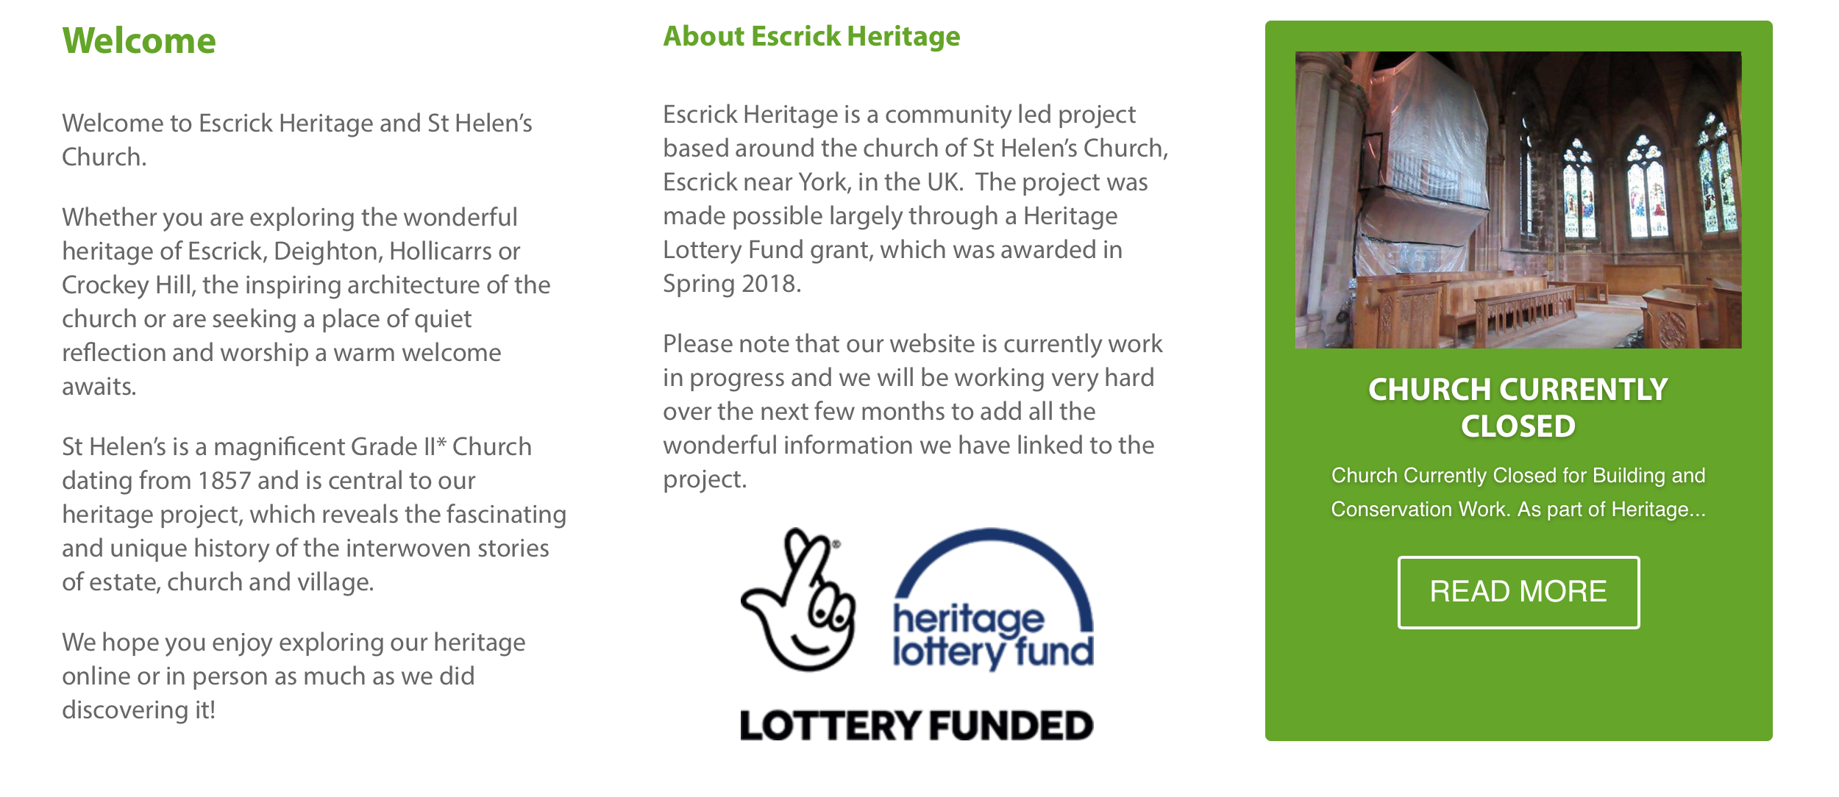
Preview of the website home page

Work on the website is going to plan and we are on target for our launch on November 7th. This will be a ‘soft launch’ which means that although the website will be live we will not have optimised it for search engines until the end of November. This will give us time to monitor the site and evaluate how well it works so we can do any final tweaks before the official launch. If you would like to help us evaluate the site please come along to the Heritage meeting at The Club on Wednesday 7th November, 7pm.

Oral History Project

The Oral History group had a very productive training session with Michelle from the Oral History Society and are now busy selecting extracts for the website and writing summaries of the interviews for the archive.
It was our initial intention to collect eight oral histories but we have decided that we would like to continue to conduct interviews in order to gather as many of the wonderful local memories as we can. The oral histories will be archived at The North Yorkshire County Record Office and they are happy to take our entire collection.

Christmas Crafts: Wreath Making

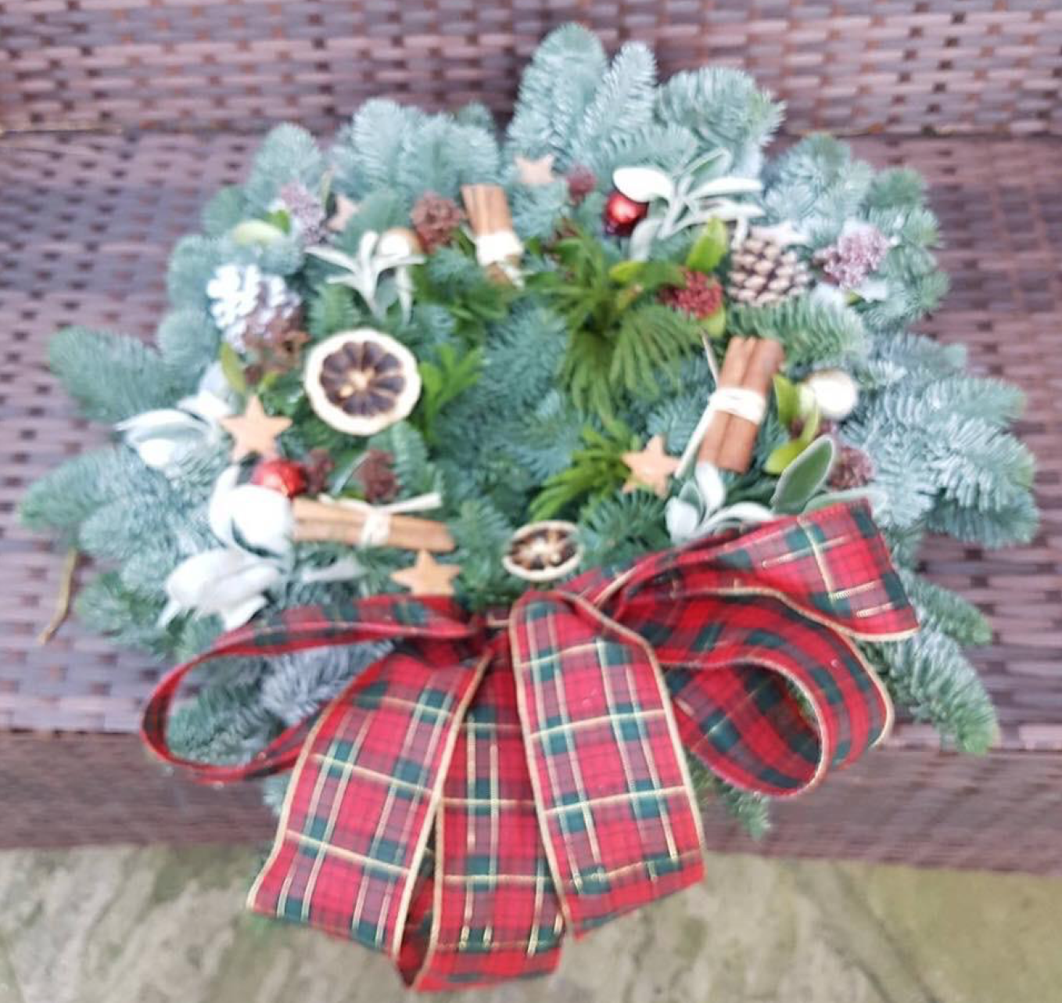

Join us for a festive and creative evening. Alison from Simply Foliage will offering advice and inspiration to help you make a beautiful bespoke wreath for your front door. Price of £20 includes all materials, mulled wine and seasonal nibbles. Monday 3rd December 7.30 Escrick Village Hall. We only have a few places left. For bookings please contact Caroline, 01904 720703 escrickchurch@gmail.com

Sword Dancing

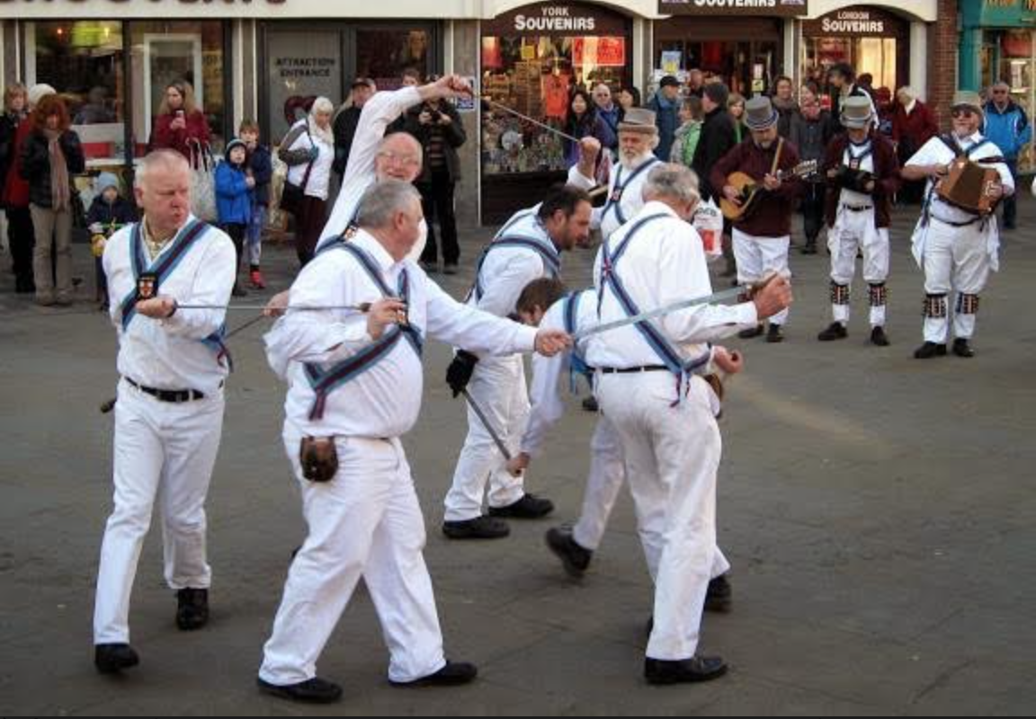
The Ebor Morris Men performing the Escrick Sword Dance

Our Heritage Engagement Officer met with Kevin Holland from Ebor Morris Men last week. Rehearsals for the dance will start in the New Year. If you have registered an interest in volunteering as a dancer you will be contacted directly.

The dance steps that we have were recorded by Cecil Sharp in 1912 when he visited Escrick and spoke to a group of local men who knew the dance.

Kevin is carrying out some research for us about this group and was wondering if anyone recognised any of the names?

The men Sharp collected from were George Skelgate, George Bell, Wakelin Goodall, William Goodall, and Henry ( Harry ) Goodall.
Bell was a painter on the estate , the Goodalls were all woodmen. The dance was taken over in the 1920’s by the WI and two of the dancers were the Hutton sister’s.

If you would like to be involved in the dancing or can contribute to the research please contact Michala escrickheritage@gmail.com

Church building Works

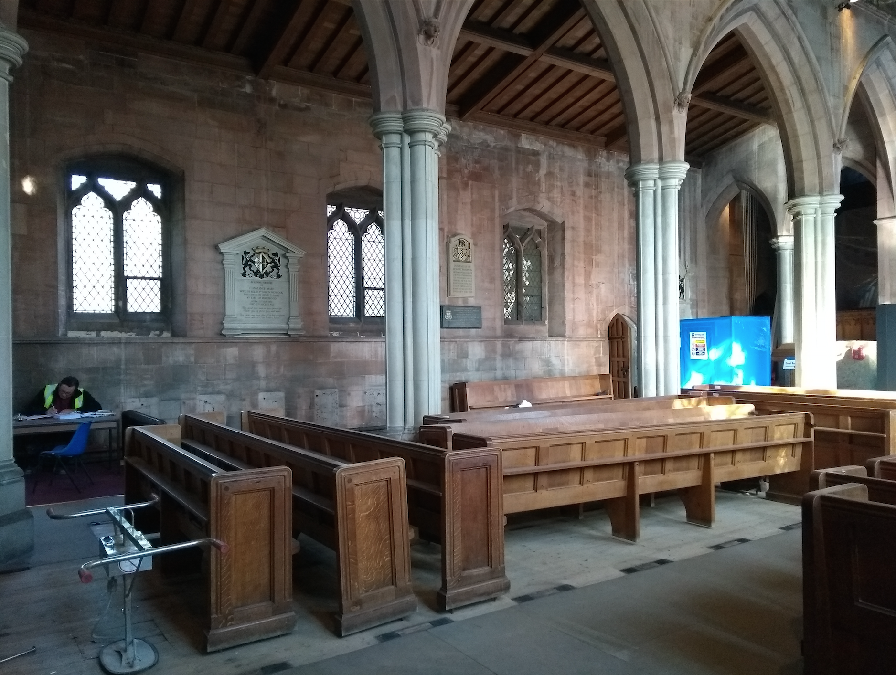
Visibly less blue pods in the Nave, but work continues in the Chancel !

Work is progressing well but the asbestos removal is taking a little longer than expected as it has been difficult to get to all the pipe runs at each end of the Church. We are pleased to say though that the back half of the Church is now completely clear, so the heating engineers and scaffolders can move in.

Escrick Heritage Monthly Meetings

Our next Heritage meeting will be on Wednesday November 7th 7.00pm at The Club. The meeting will provide an opportunity to catch up with progress on the project and preview our new website. We will also be discussing the permanent interpretation and guidebook. All welcome.

Volunteers

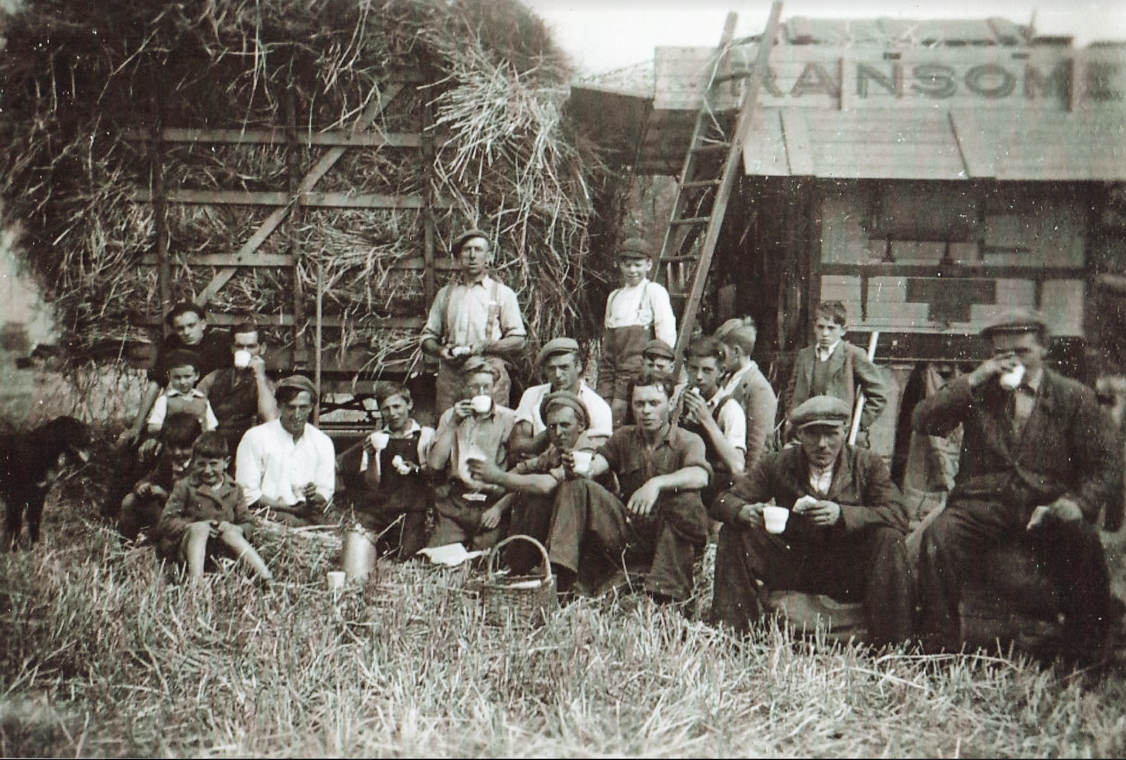
Image from Community Archive, G Shearsmith

Over the next few months we will be working on all aspects of interpretation. If you would like to get involved we are looking for people to carry out small pieces of research, locate images, edit and proof work.

We are also looking for volunteers to spend an hour or two trialing and feeding back on the website.

Please contact Michala for further information or come along to the Heritage meeting on November 7th.

Dates for Your Diary

7th November Heritage meeting, The Club
7-8.30pm
3rd December Wreath Making Workshop, Village Hall, 7.00pm
6th April Family History Workshop, St Helen’s 10-3.30pm

If you would like more information about anything in the Newsletter or would like to volunteer please contact, Michala Pearson escrickheritage@gmail.com or Caroline Wandless escrickchurch@gmail.com

If you no longer wish to receive this newsletter please contact escrickheritage@gmail.com

