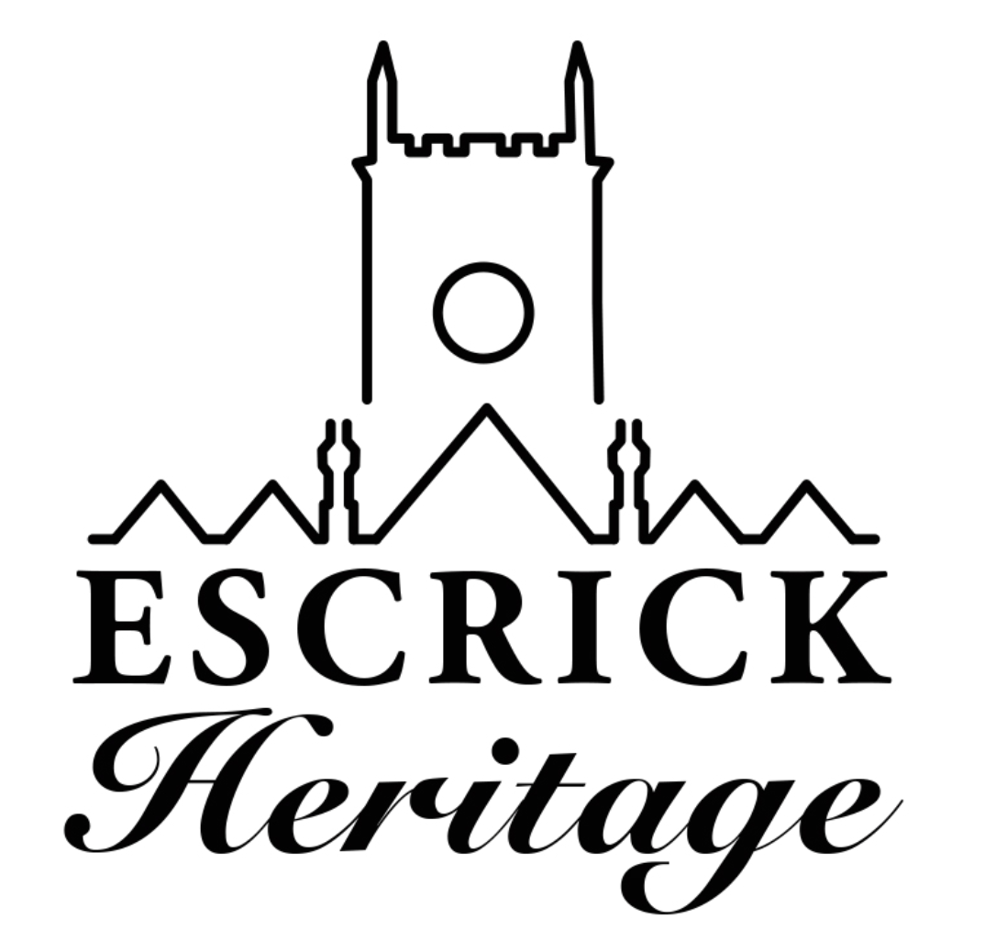
November Newsletter
Issue 6

Welcome to our sixth volunteer newsletter! The newsletter is produced every month to keep you up to date with the project and to celebrate our progress.

Media Vision

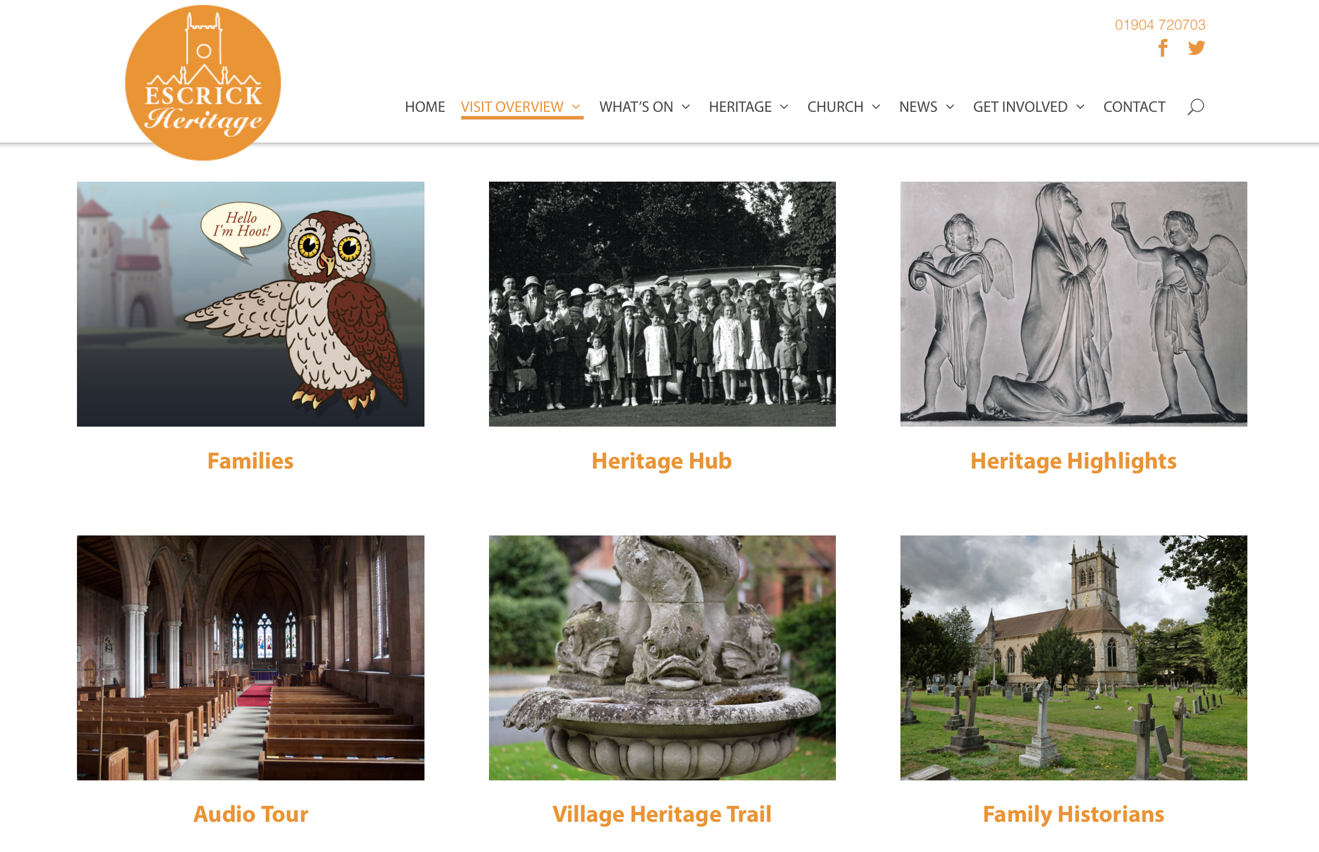
Preview of part the visit page

The website will be going live on November 30th but if you would like to look at it before then please go to,

https://www.escrickheritage.org/home-page/

As we have so much fantastic material to put on the site you will see that some sections such as the community archive and research section are work in progress but we will be adding to them on a regular basis over the next few months. We’d love to hear your feedback about the site and it is early days so if you find any glitches please let us know so that we can put them right.

Village Heritage Trail

Work has started on the village trail with a very productive meeting to decide the route of the trail and basic design concepts for the leaflet. Our trail volunteers are now surveying the route and marking down points of interest to research.

Church Guide Book

This is making steady progress and after several consultation meetings with volunteers we have our first draft which Chris from Media Vision is mocking up for the volunteer group to discuss.

Community Panels

We now have all the panels back from Chris and will be meeting in December for our final proof before taking them to the project partners for approval. A huge thank you to everyone who has worked so hard on getting these done. Our next interpretation project will start in the New Year, please let Michala know if you would like to be involved.

Stained Glass Workshop

Join Jo-Ann Eisenberg from Hannah Stained Glass to create your own simple piece of stained glass. During the day you will choose a 6 piece glass design and then learn how to cut glass, choose colours, cut out and grind the pieces to fit, lead solder, cement and clean your own piece of stained glass.
Saturday 11th May 10-5pm £50 including materials, please contact Caroline, escrickchurch@gmail.com Places are limited so please book early to avoid disappointment.

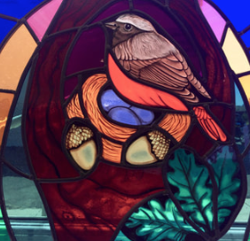
An example of Jo’s work.

Sword Dancing Volunteers Wanted!

As part of the heritage project we will be reviving the Escrick Sword Dance and have enlisted the help of the Ebor Morris Men to help us do it.

If you think this might be something you’re interested in doing please join us on
Wednesday 3rd April 7.30pm in the Church for a taster session.

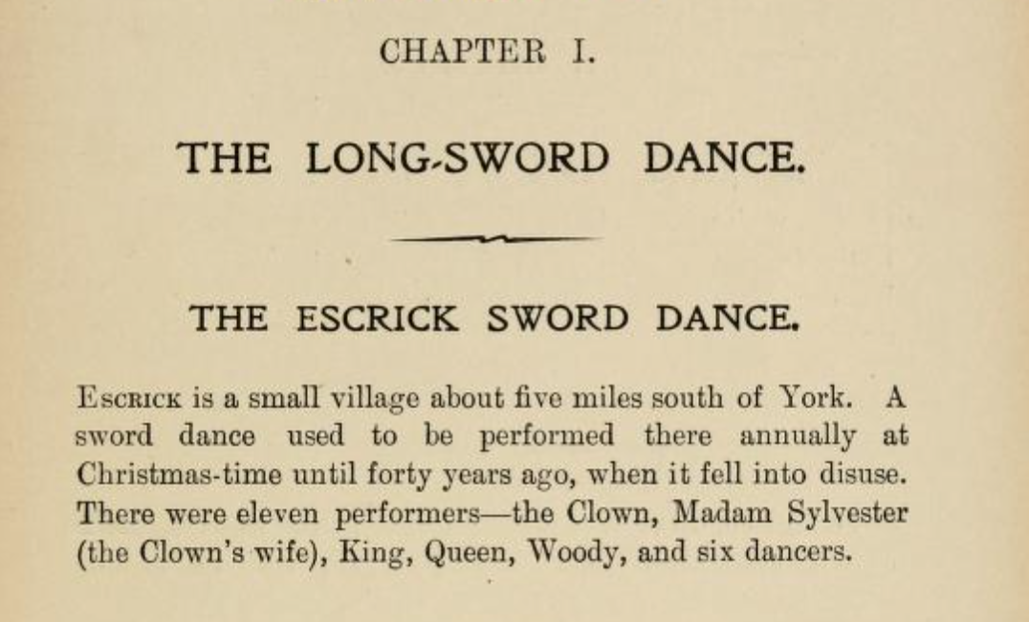

Extract from Cecil Sharp’s book on sword dancing 1912

Following on from the taster session rehearsals will take place on Saturday 13th April 10-3pm, then Wednesday evenings 7.30-9.30pm, 17th April to 19th June with a preview (for friends and family) on Wednesday 5th June and performance on Sunday 23rd June at the end of project celebration.

Church building Works

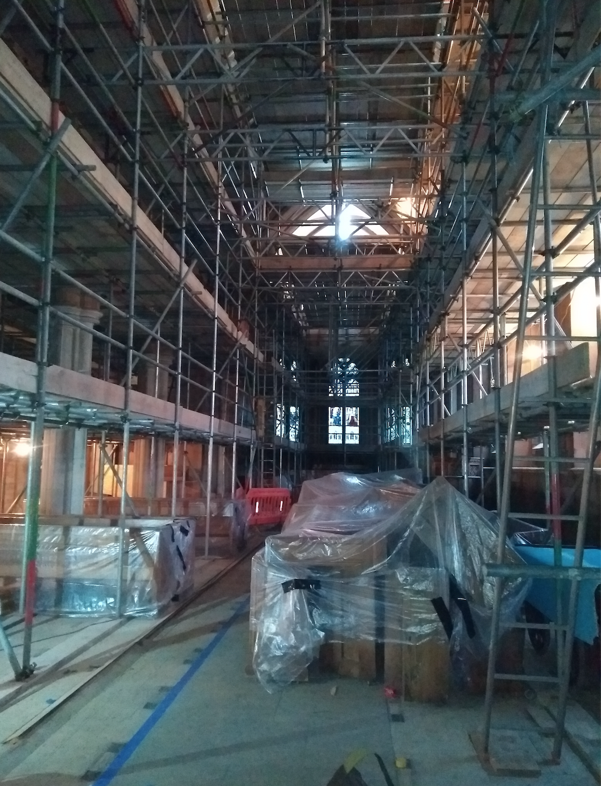

The last few weeks have seen lots of progress, the asbestos removal has been completed, the final elements of the internal scaffolding are in place, the heating, electrical and PA system contractors are all making good progress and the stone masons are now on site too. Church is full of scaffolding, including the chancel. From the top platform it is now possible to stand and touch the ceiling in the Nave!

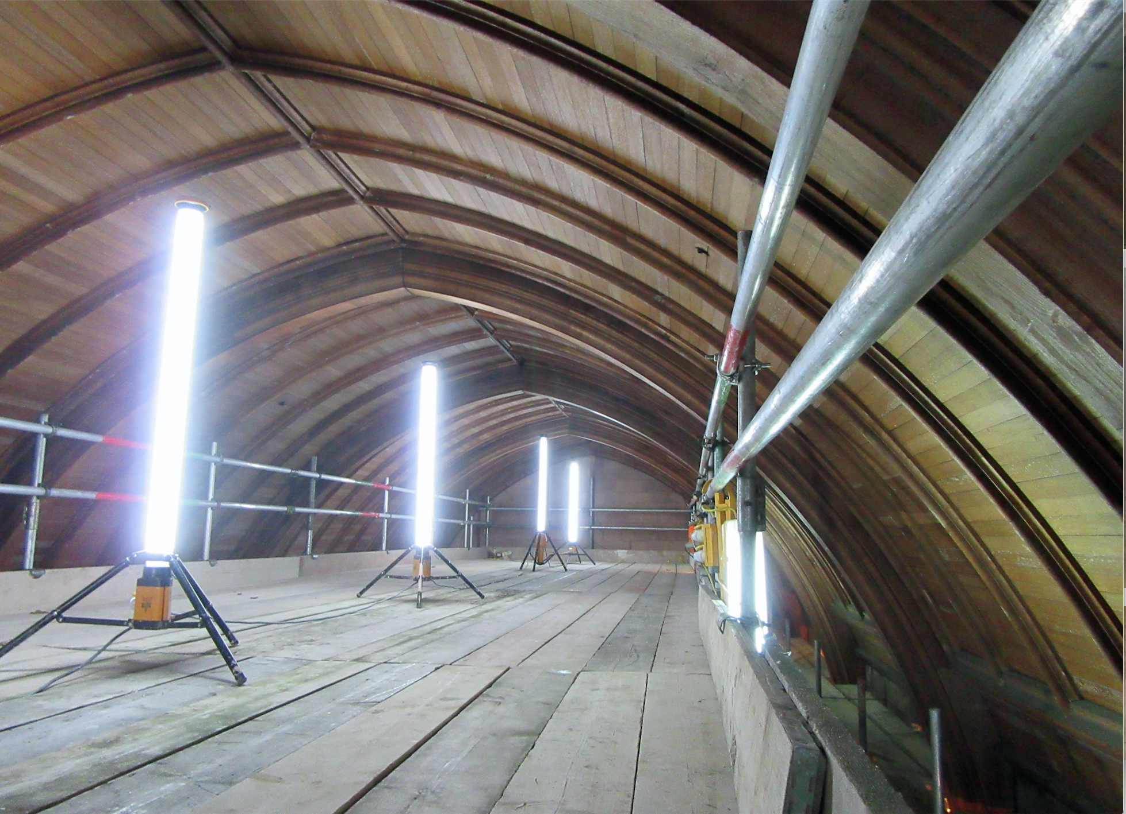

Escrick Heritage Monthly Meetings

Our next Heritage meetings will be on Wednesday January 9th , February 6th and March 6th 7.00pm at The Club. The meetings will provide an opportunity to catch up with progress on the project, find out about volunteering roles and share research.

Dates for Your Diary

3rd December Wreath Making Workshop, Village Hall, 7.30pm SOLD OUT
5th December Community Panels meeting 7.30pm
9th January Heritage meeting, The Club
7-8.30pm
6th February Heritage meeting, The Club
7-8.30pm
6th March Heritage meeting, The Club
7-8.30pm
3rd April Sword Dancing Taster, St Helen’s 7.30pm
6th April Family History Workshop, St Helen’s 10-3.30pm
11th May Stained Glass Workshop, St Helen’s 10-5pm

The next Newsletter will be in January.

Wishing everyone a Happy Christmas and Joyful New Year.

If you would like more information about anything in the Newsletter or would like to volunteer please contact, Michala Pearson escrickheritage@gmail.com or Caroline Wandless escrickchurch@gmail.com

If you no longer wish to receive this newsletter please contact escrickheritage@gmail.com

