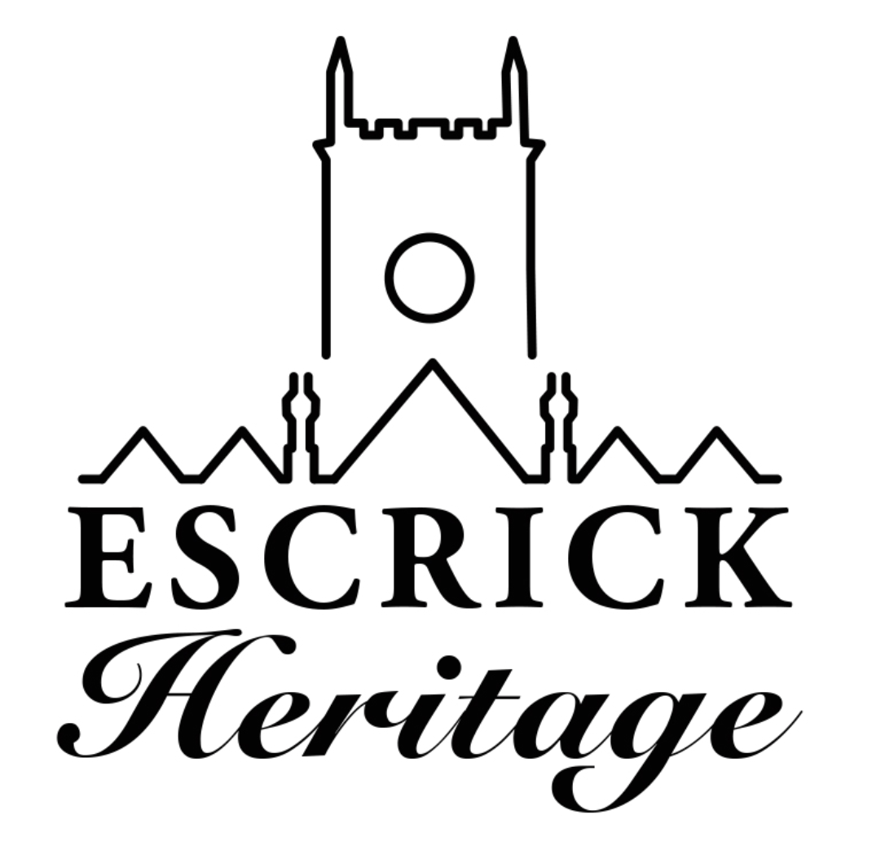
February Newsletter
Issue 8

Welcome to our eighth heritage newsletter! The newsletter is produced every month to keep you up to date with the project and to celebrate our progress.

Community Panels

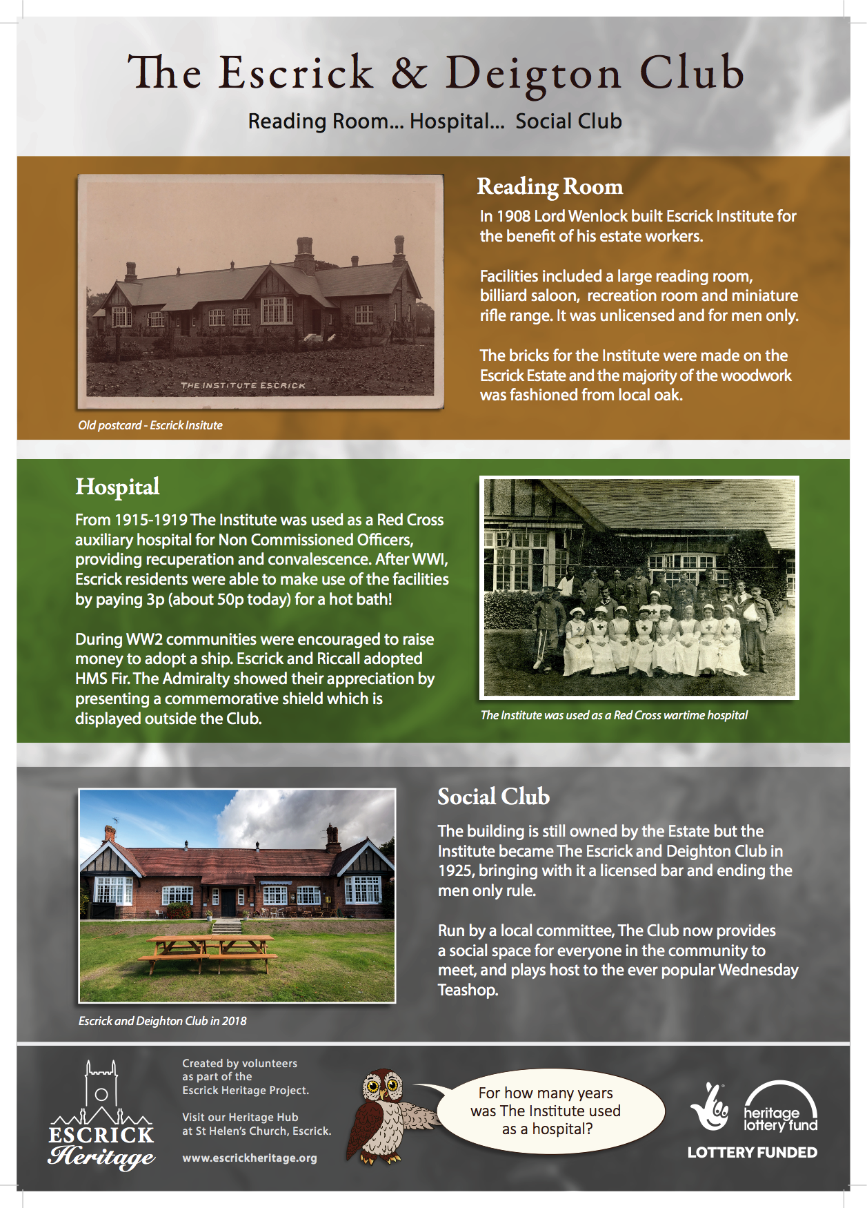

A huge thank you to all our volunteers who have worked on the community panels. We have now met with all our partners and they are delighted with the results. The panels will be going to print in the next couple of weeks and will then be found at The Surgery, The White Swan, The Black Bull, The Club, The Village Hall and The Parsonage.

Community Archive Exhibition

We are creating a temporary exhibition to promote and showcase our community archive. Five volunteers have looked through over 500 images and have selected 16 to create the exhibition. We intend to give a bit of background information to each image ,so if you have anything you can tell us about these three images please do get in touch. escrickheritage@gmail.com

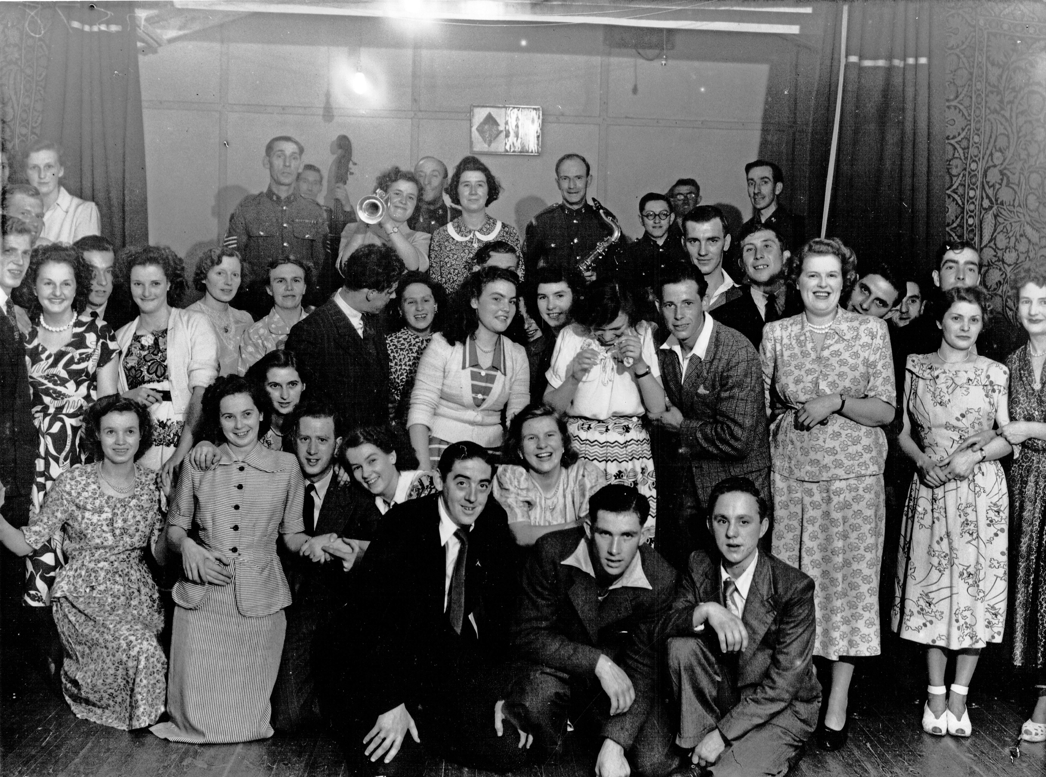

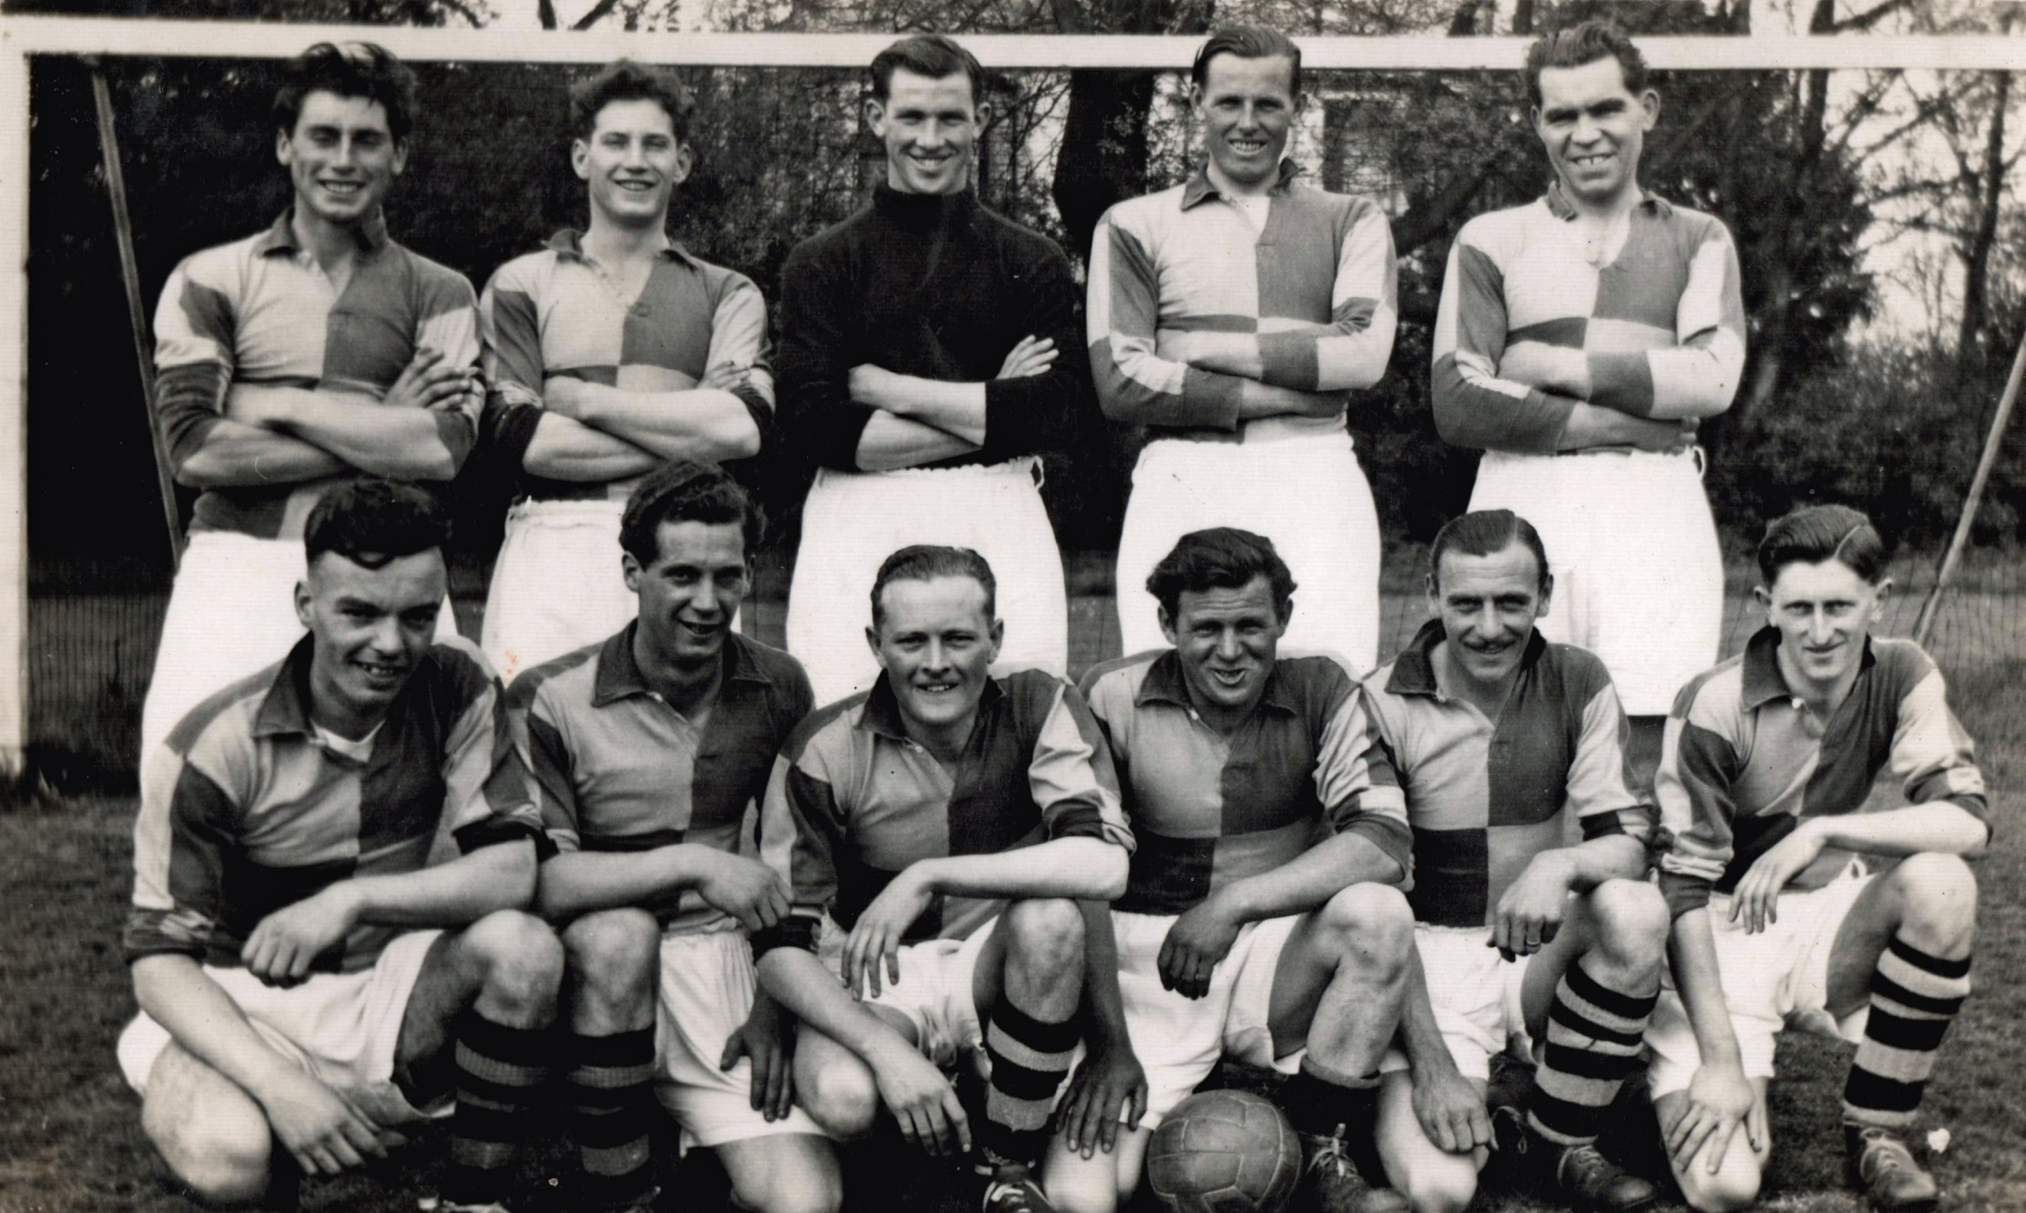

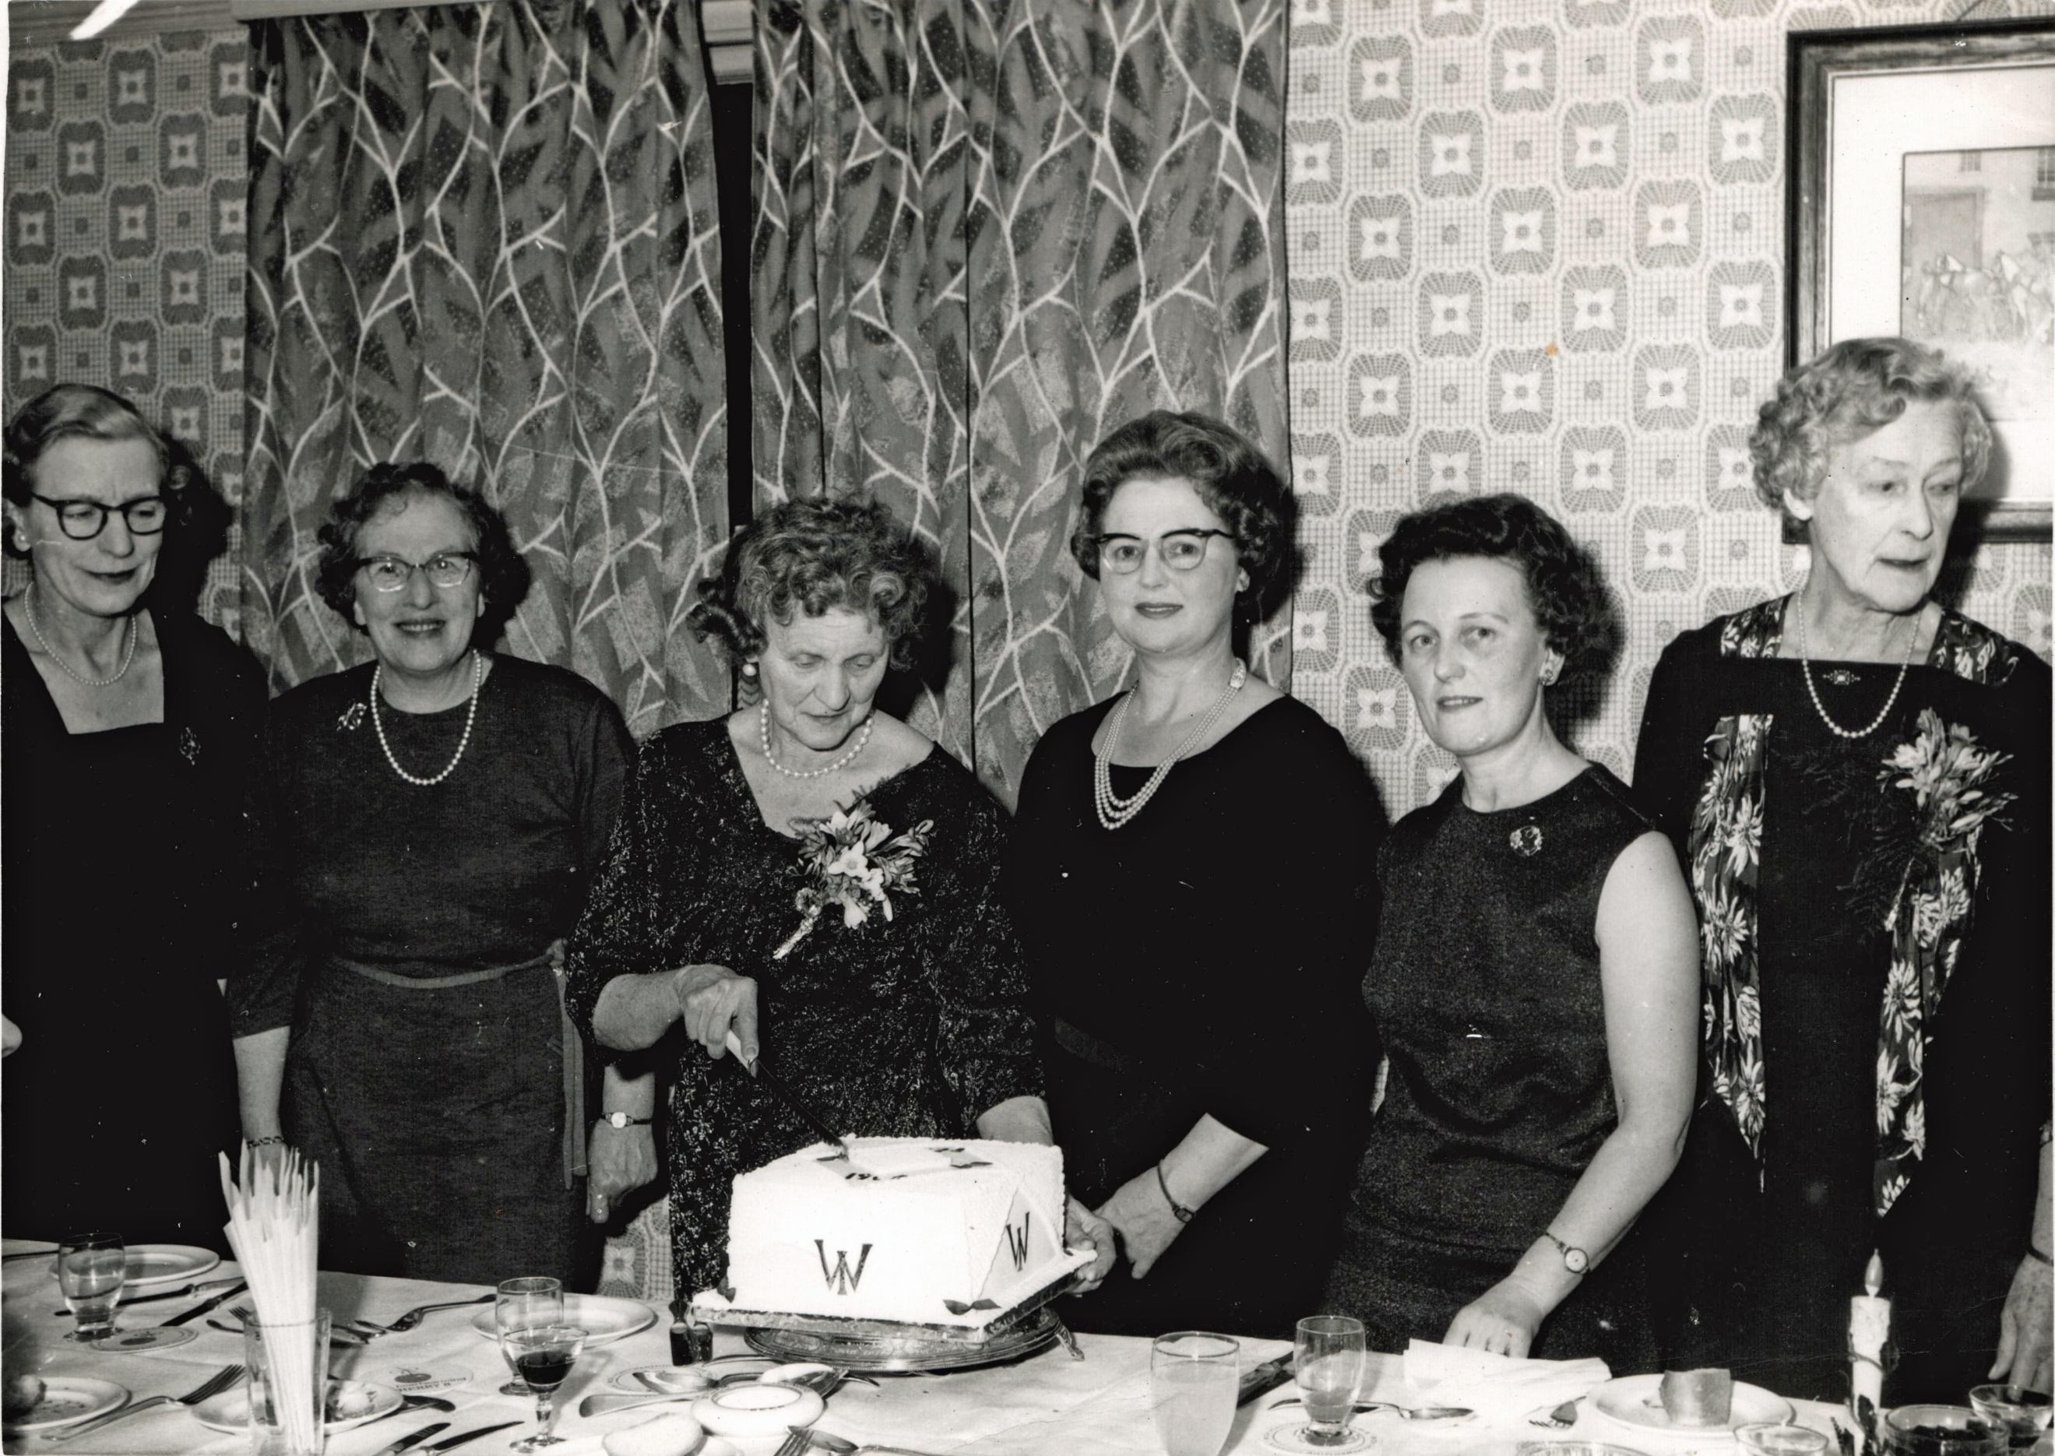

Heritage Meetings

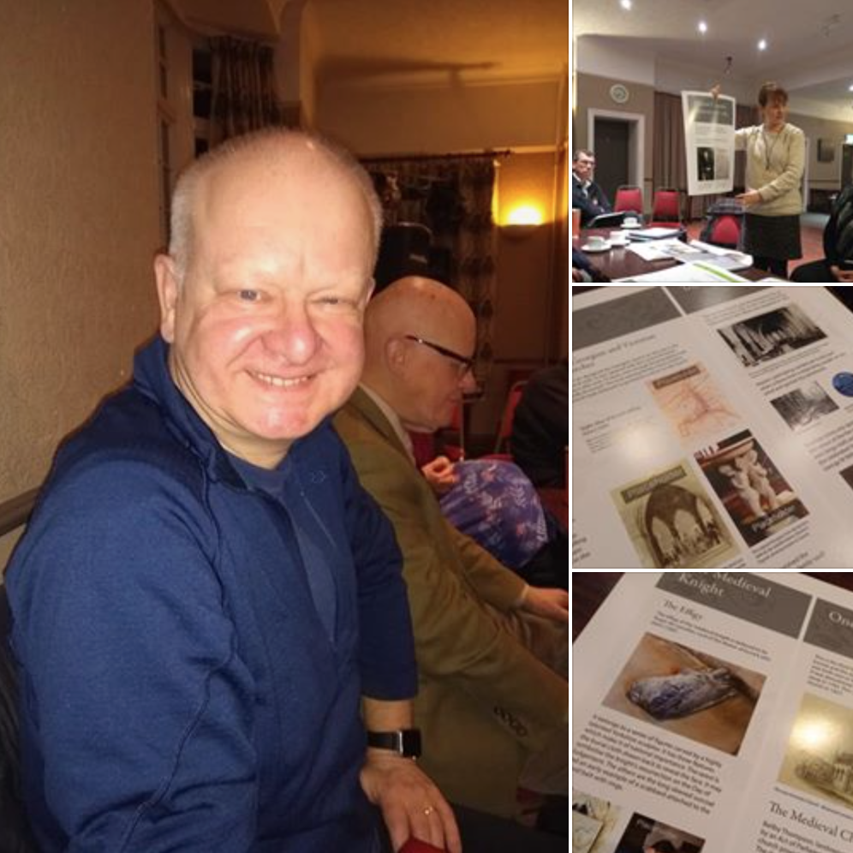

It was great to see so many people at our February meeting. We had a fascinating talk about the Escrick Sword Dance by Kevin Holland from Ebor Morris as well as sharing our latest discoveries and finds. There was even a pre-view of the main church interpretation. Our next meeting will be Wednesday March 6, 7pm at The Club, please do come along to catch up with the project and share your memories and stories.

Sharing Memories

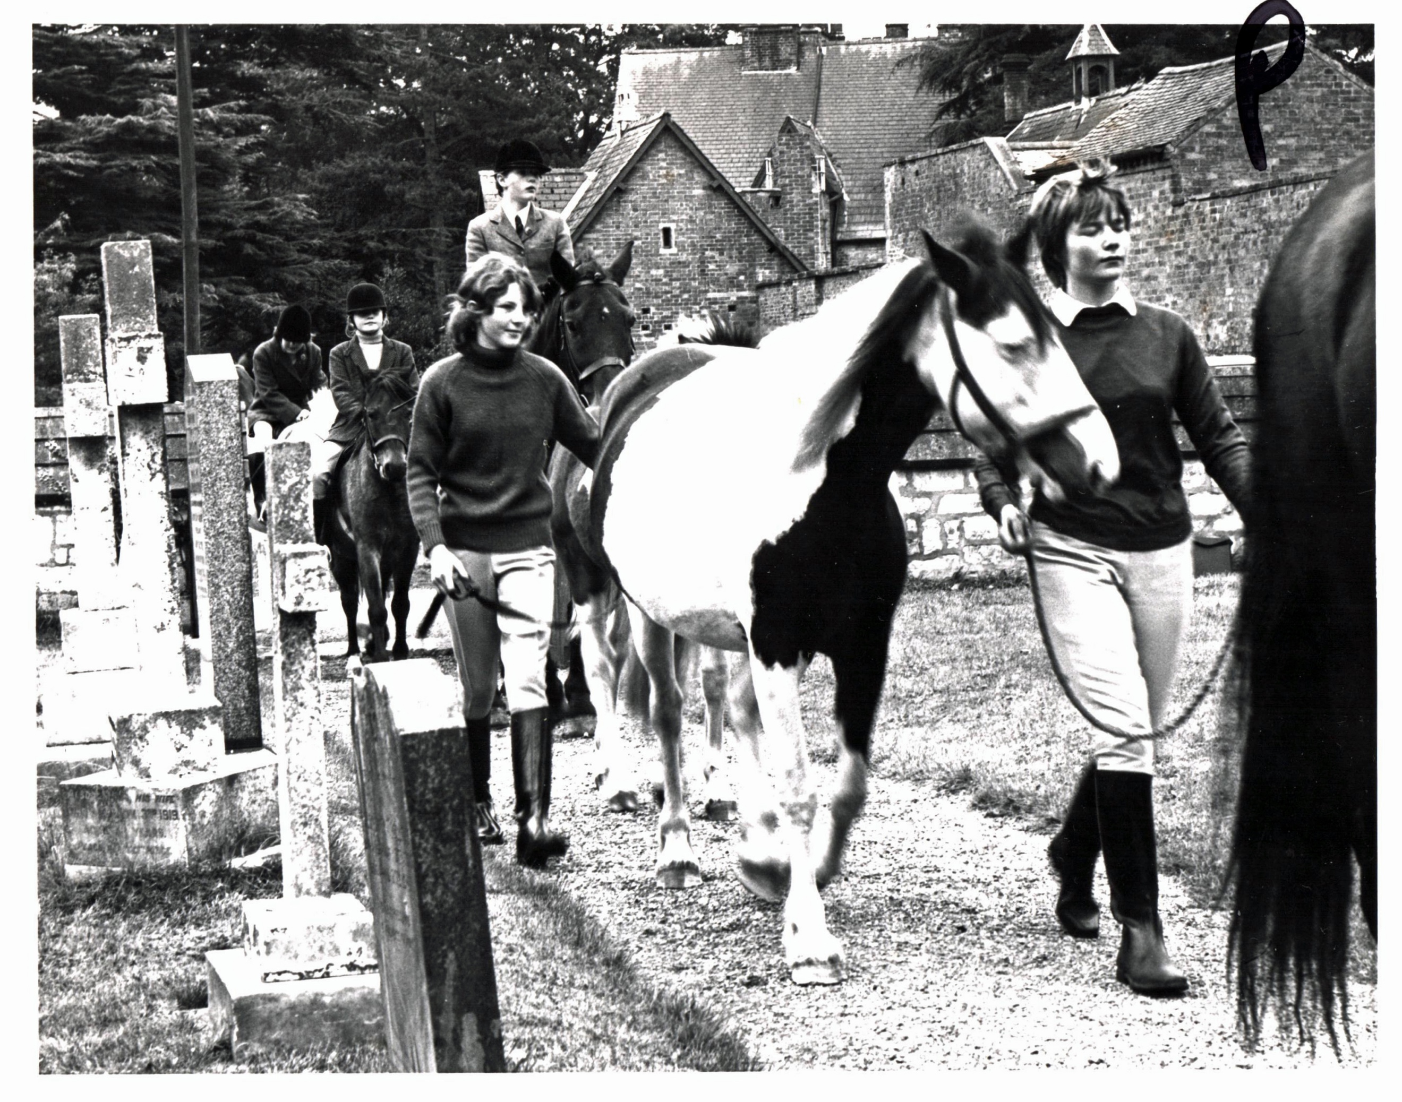
Horseman’s Sunday

Do you have any images or memories of special celebrations in Escrick that you would like to share with us? We’d love to hear about anything from parties at the Village Hall to Nativity Plays in church, Garden Fetes to Harvest Festivals. We will have the scanner in church if you would like to add anything to the community archive and of course we’ll be providing teas and coffees from our new servery. Saturday 13th April 10-12pm St Helen’s.

Family History Workshop

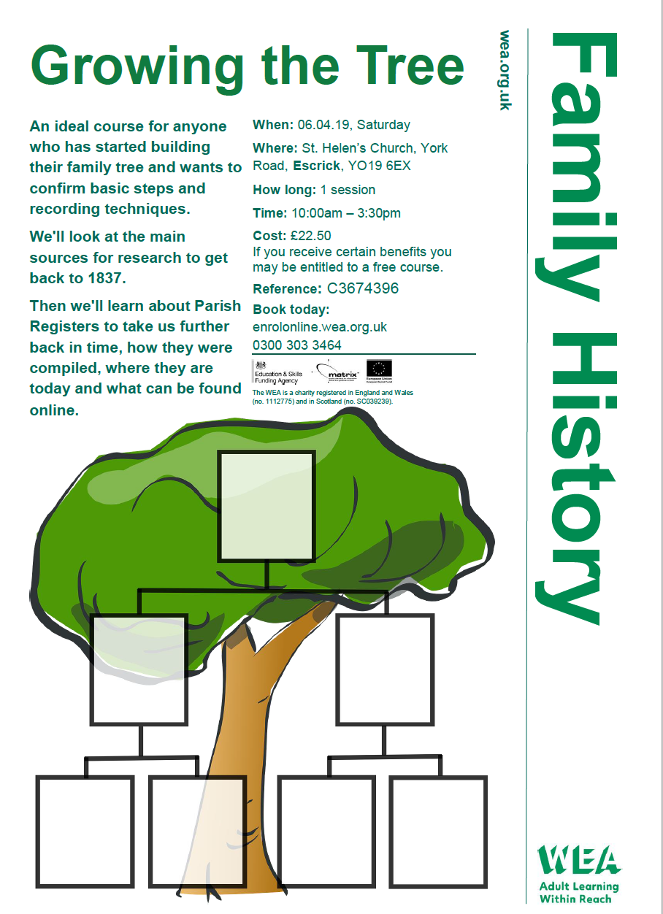
This promises to be a fantastic introduction to tracing your family tree. Please book directly with WEA enrolonline.wea.org.uk or contact Michala for more information.
Building Work

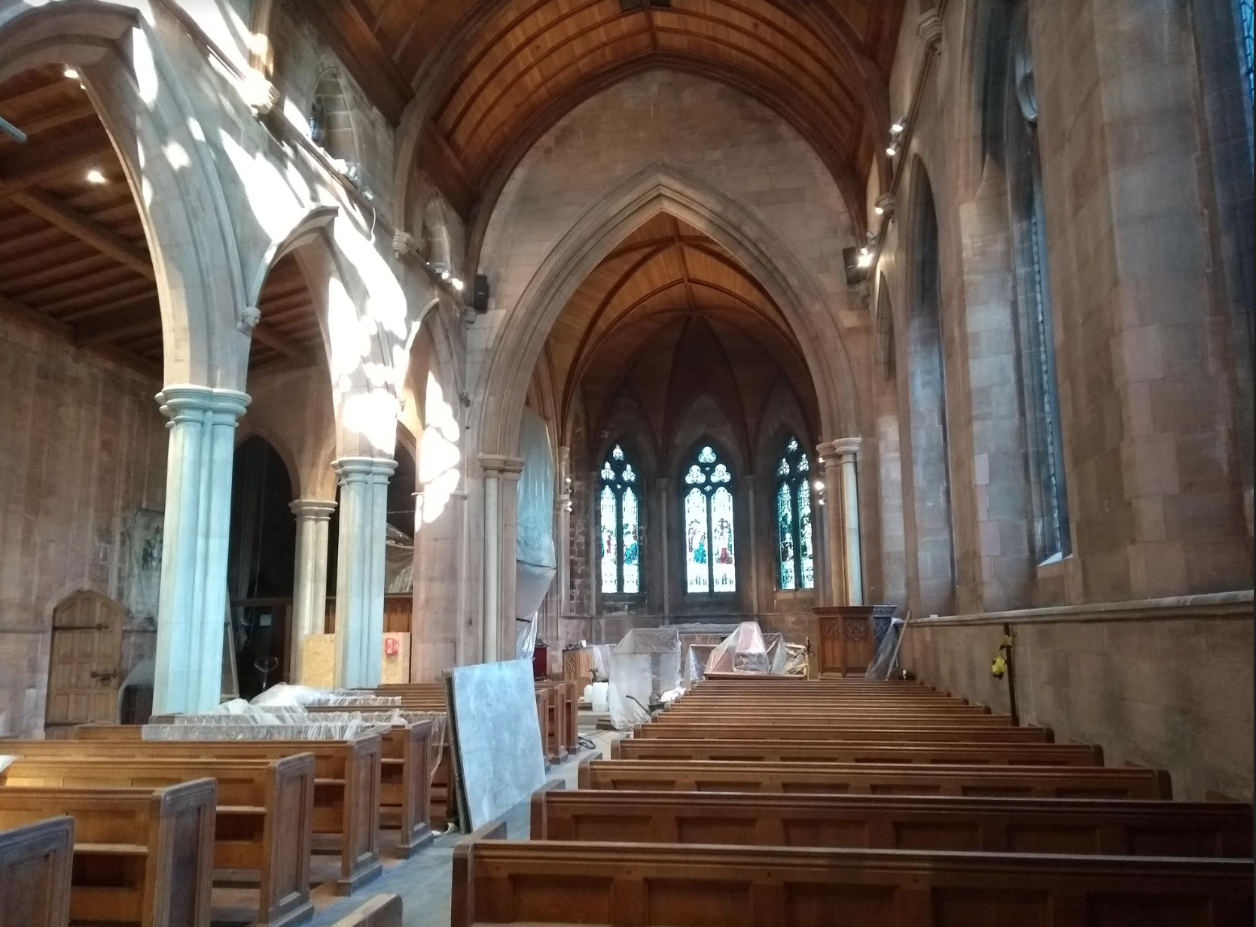

Things are now moving quickly. Most of the scaffolding is down, the lighting is almost ready to be commissioned, the first heat has gone through the central heating pipes, preparations have started for the new paving outside the main door, ‘Legless’ and Lady Caroline have moved ready for cleaning and most of the pews are now back in place. The walls, ceiling and windows look great and overall the building looks much more light and airy. We are not yet sure exactly when we will be back in church, but we will definitely be in for Easter. Not long now!

Dates for Your Diary

6th March Heritage meeting, The Club 7pm
25th March Tour Guide Training, 7-8.30pm
1st April Tour Guide Training, 7-8.30pm
3rd April Sword Dancing Taster, St Helen’s 7.30pm
6th April Family History Workshop, St Helen’s 10-3.30pm
13th April Sharing Memories, St Helen’s 10-12
17th April – 19th June Wednesdays Sword Dancing, St Helen’s 7.30-9.30pm
20th April Hands on History Easter Event, St Helen’s 1-4pm
11th May Stained Glass Workshop, St Helen’s 10-5pm
11th-17th May Church Survey
13th May Heritage Hub , St Helen’s 1-4pm
10th June Heritage Hub, St Helen’s 1-3pm
If you would like more information about anything in the Newsletter or would like to volunteer please contact, Michala Pearson escrickheritage@gmail.com or Caroline Wandless escrickchurch@gmail.com
If you no longer wish to receive this newsletter please contact escrickheritage@gmail.com

