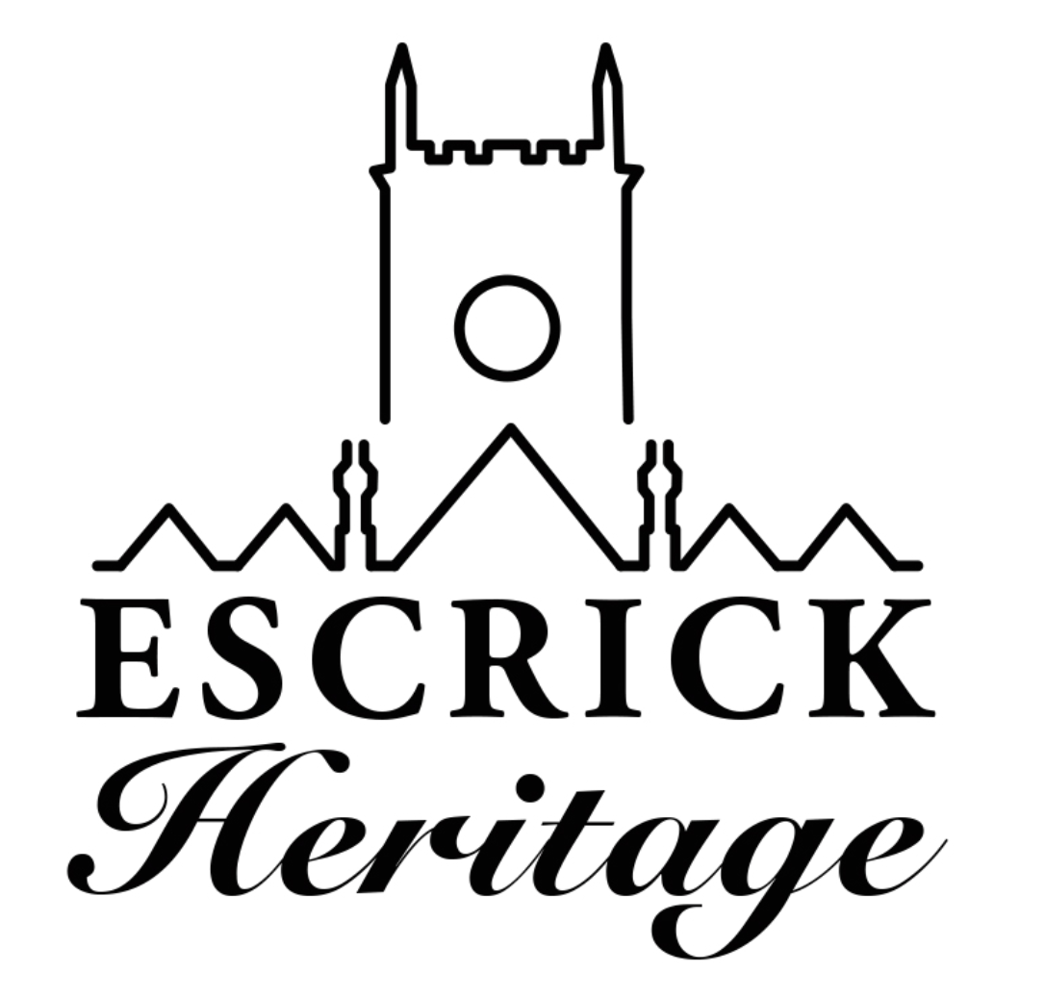
February Newsletter
Issue 9

Welcome to our ninth heritage newsletter! The newsletter is produced every month to keep you up to date with the project and to celebrate our progress.

Volunteer Celebration Lunch

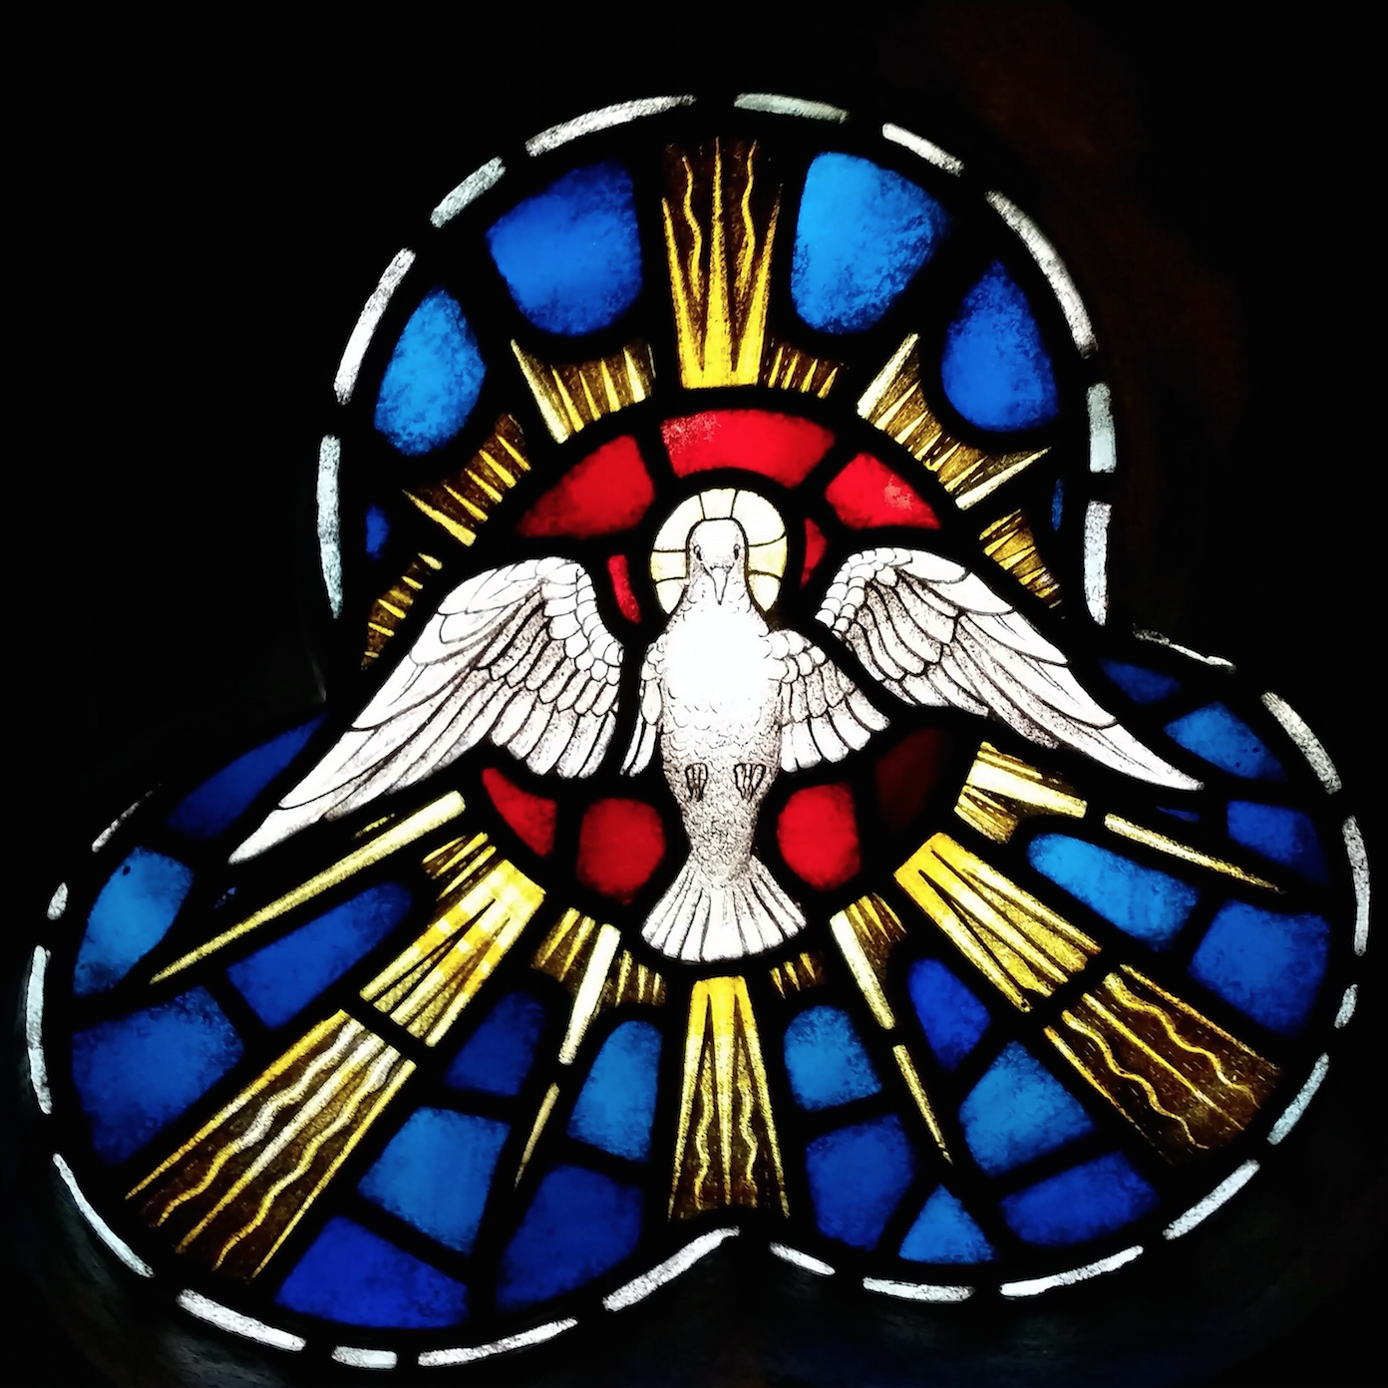
The stained glass looking truly stunning after a professional clean

In order to celebrate being back in church and to say thank you to everyone who has helped so far with the project, we would like to invite you to join us for a light lunch and an opportunity to have a look at the work that has been carried out in church. Saturday 13 April 12.30-2.00 RSVP escrickchurch@gmail.com

The Escrick Ring

York Museum Trust Image by Kippa Matthews

We are delighted to announce that Lucy Creighton, Yorkshire Museum’s Curator of Archaeology, will be giving a talk on the spectacular Escrick ring and offering us a rare opportunity to get up close to the ring near to the spot where it was discovered.
Lucy will share with us how archaeologists unlocked the story of the Escrick Ring and how objects like this are crucial to our understanding of the mysterious Anglian period in Yorkshire. Tuesday 14 May
Doors open 6.40pm Talk starts at 7 pm
Entrance by ticket only: £5 to include drink, cheese and nibbles. Contact escrickchurch@gmail.com to book

Queen Margaret’s Walk and Talk

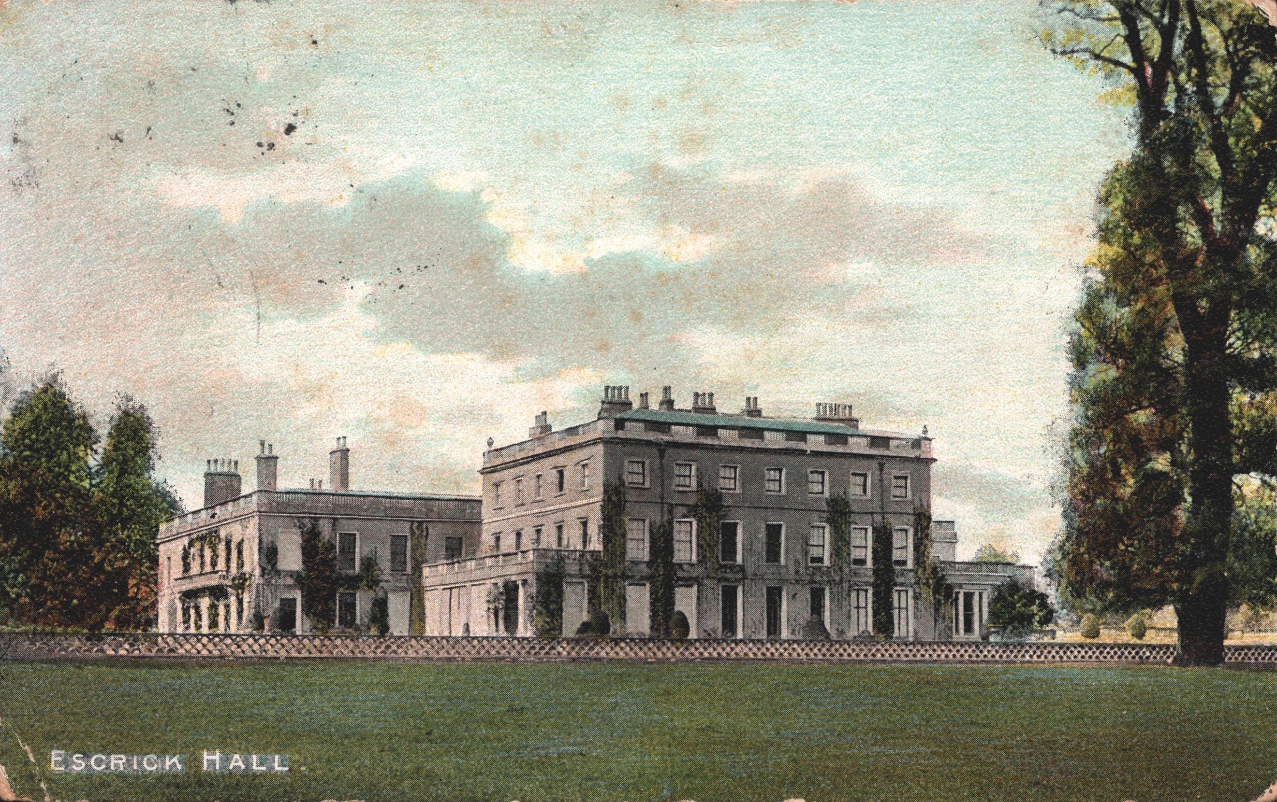

Bill Hulley who worked at Queen Margaret’s for many years will be taking us on what promises to be a fascinating historical tour of the grounds. Wednesday 24 April 10am with tea and coffee after in church. Places are limited please contact escrickchurch@gmail.com to reserve a place.

Heritage Meetings

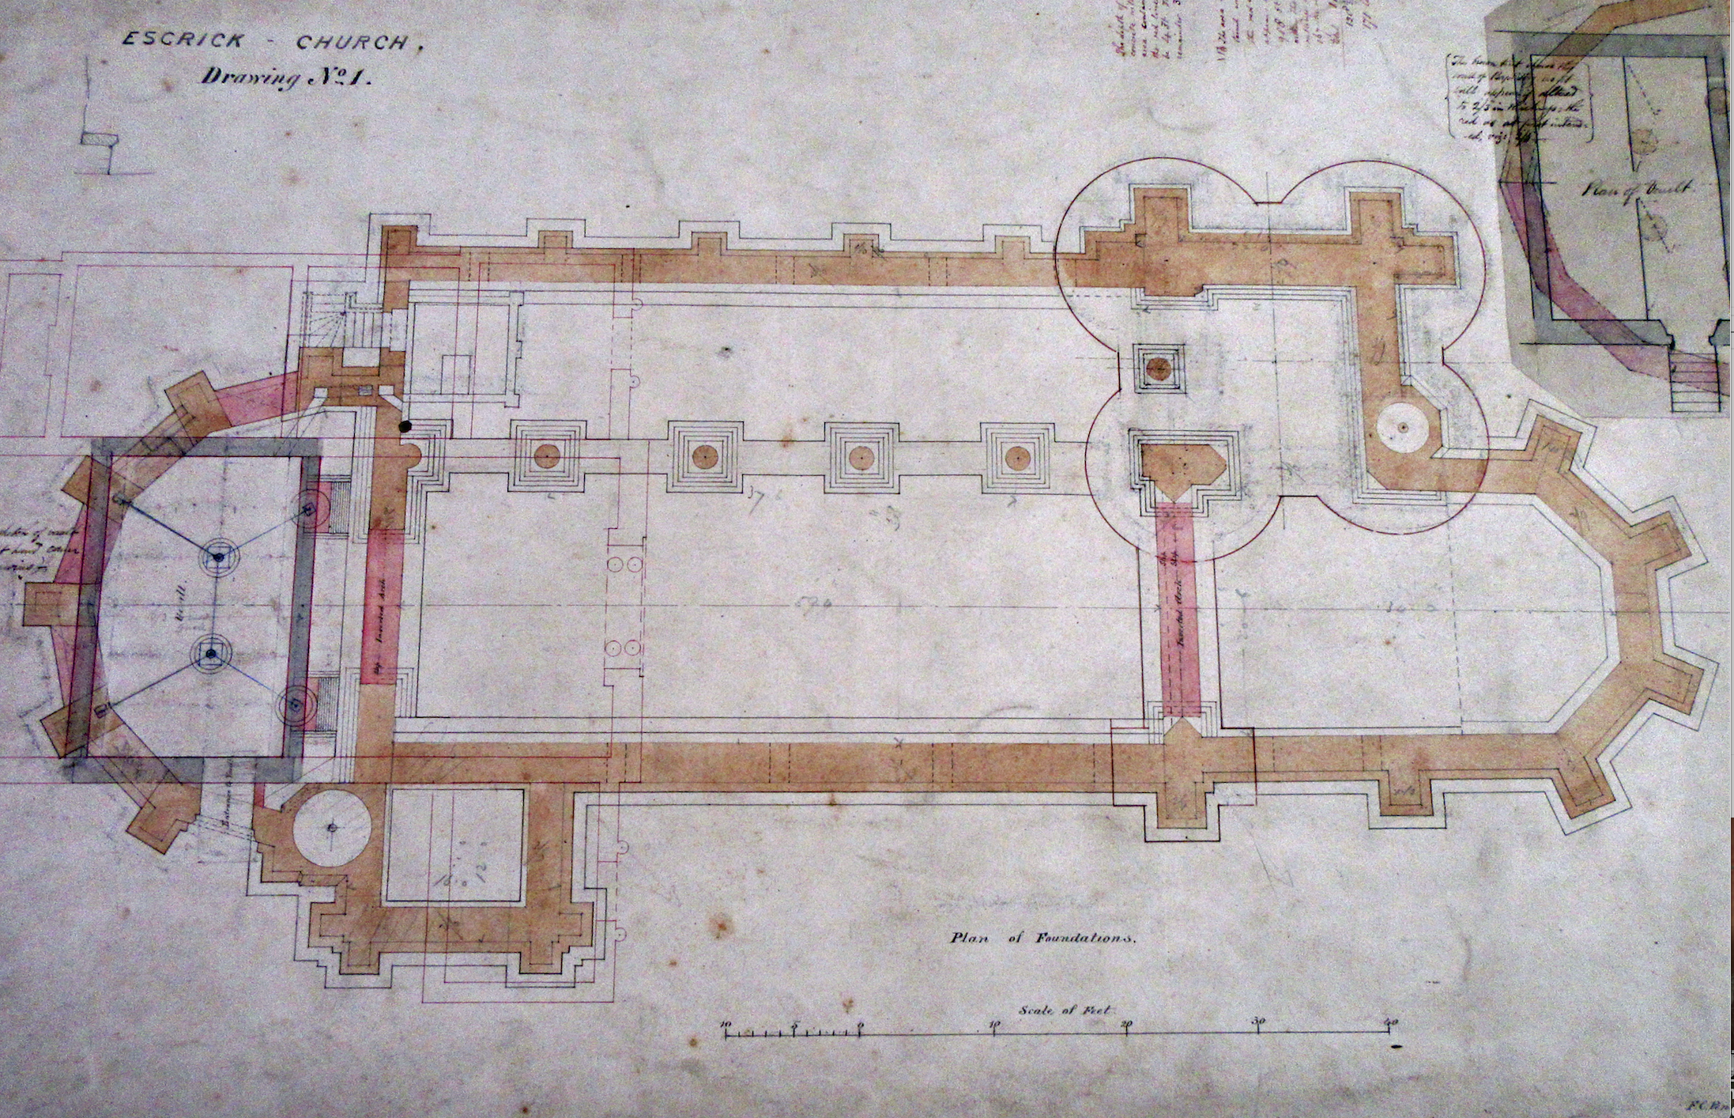
Penrose’s original plans sourced from the Borthwick by volunteers

A slight change of date for our next meeting which will take place on Tuesday 2 April 7-8.30pm in the Club. After that we will be back to the first Wednesday of the month and back in church! Please do come along to this relaxed social event to keep up to date with the project, share stories, memories and discoveries. Everyone welcome.

Family History Workshop – Date Change

This workshop will now be taking place in church on Saturday 6 July10-3.30pm
For more information or to book please go to enrolonline.wea.org.uk or contact Michala.
Community Archive Exhibition

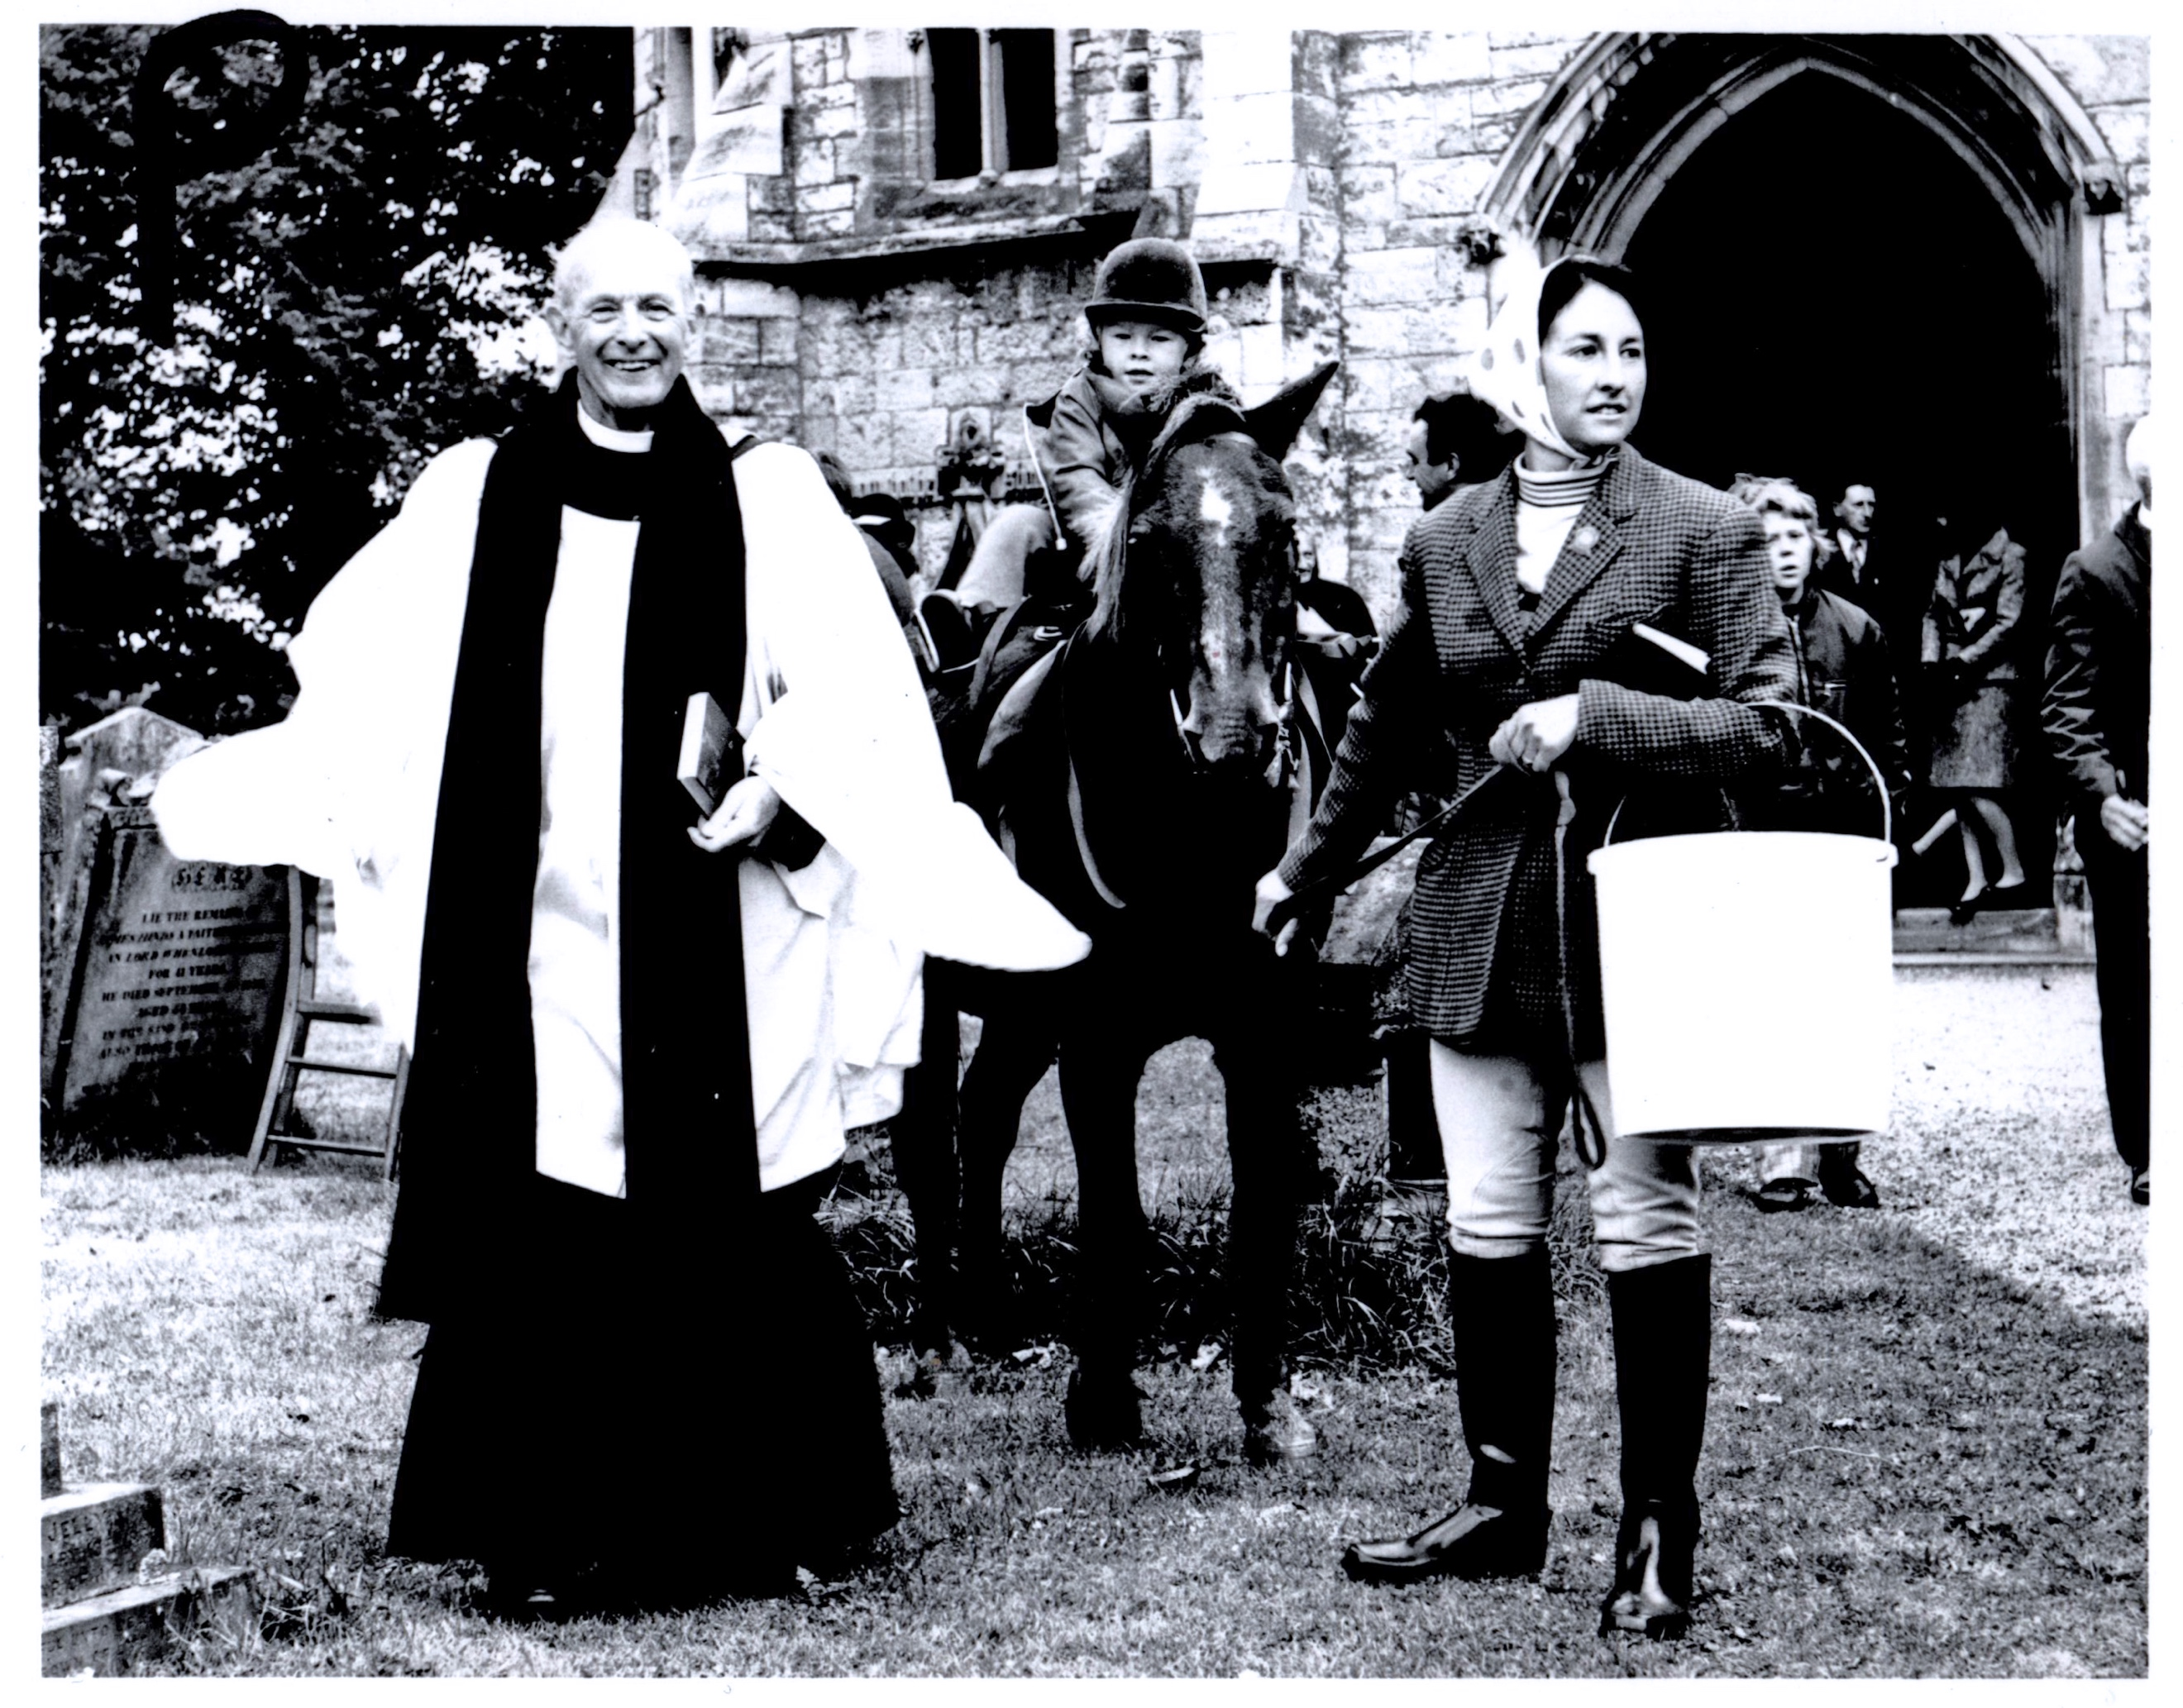

If anyone can remember Horseman’s Sunday or knows anymore about this picture we’d love to hear from you. We’ll be sharing memories at the church on Saturday 13 April 10-12 or you can contact us on escrickheritage@gmail.com

Grave Yard Plan

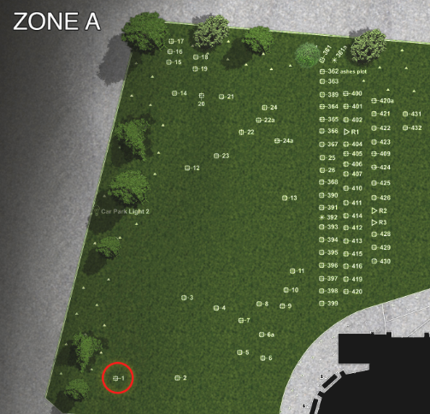

Thanks to our volunteers, the Graveyard plan is now complete and Chris from Media Vison is preparing it for the website. Once on the website, photographs will be added of each gravestone.

Tour Guiding – Date Change

If you would like to join us for the tour guide training please note that the dates have changed so that we can practice in church. If you are unable to attend but would like to volunteer please contact Michala. Tuesday 23 April 10-12 and Tuesday 30 April 10-12

Hands on History Easter Event

From our family Lego design challenge to build a vehicle to transport an egg as far as possible, through to a traditional egg roll, tricky trails, Easter themed crafts, heritage images of village transport, church tours and a pop up café there is something for all the family to enjoy. Saturday 20 April 1-4pm

Building Work

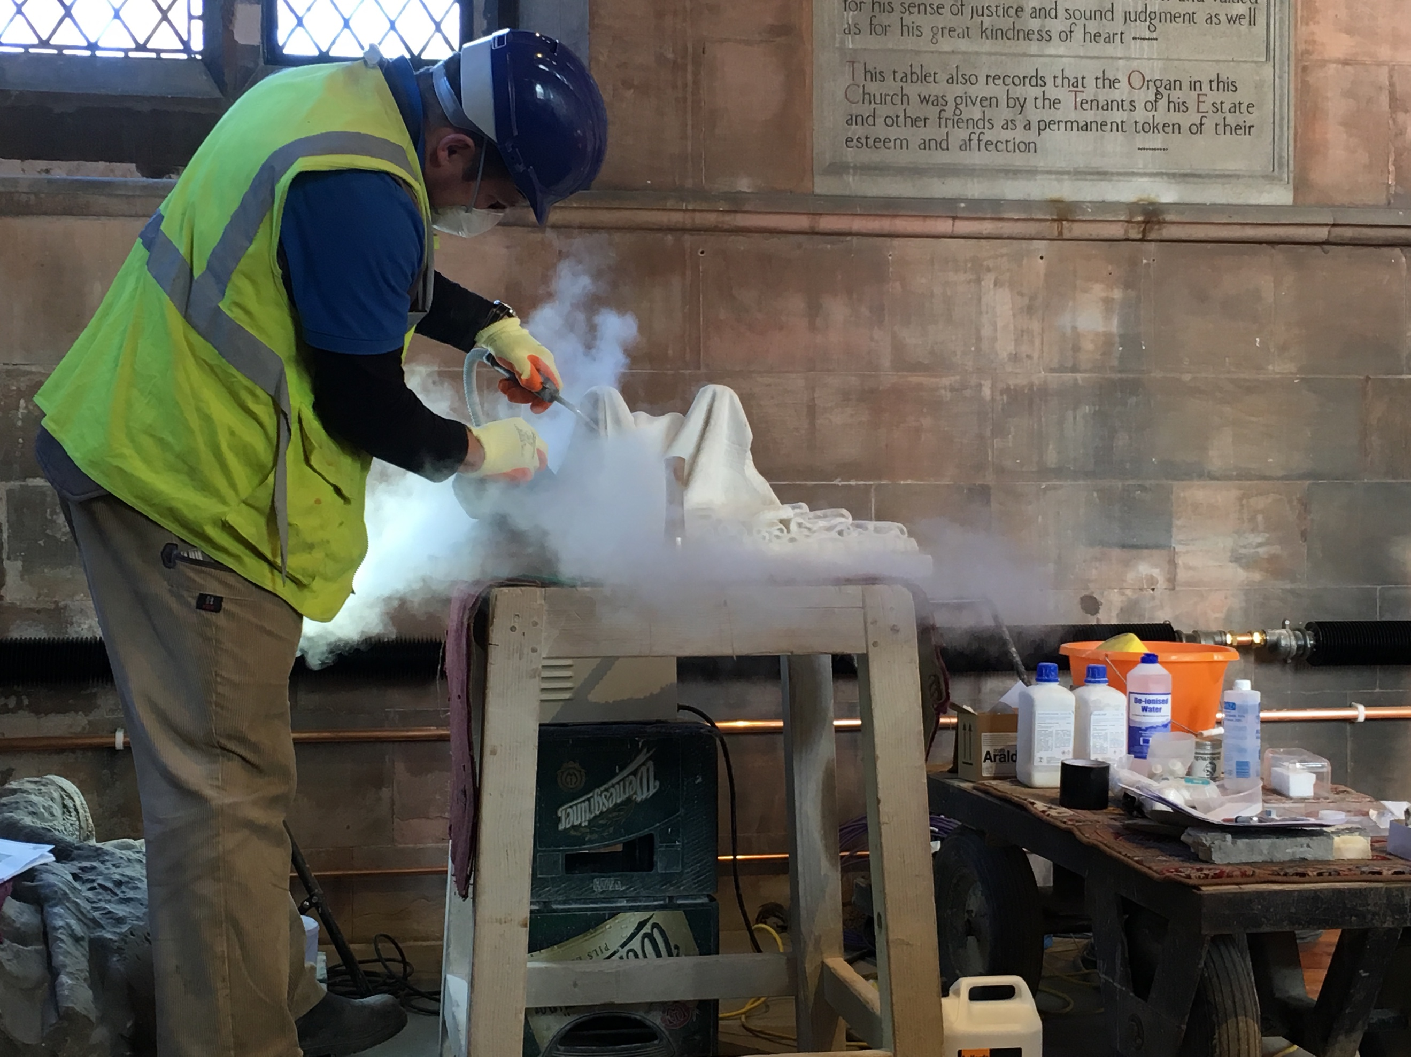
Cleaning Lady Caroline

Things are coming along now in leaps and bounds and very soon we will be able to start holding events in Church. There will though still be things to finish off such as the fitting of the secondary doors and staircase in the vestry which will be fitted around the end of April. Please do take the opportunity to come along to one of the events to see first-hand what has been happening over the last 6 months.

Dates for Your Diary

3 April Sword Dancing Taster, Village Hall 7.30pm
13 April Sharing Memories, St Helen’s 10-12
13 April Volunteer Lunch 12.30-2pm
17 April – 19 June Wednesdays Sword Dancing, St Helen’s 7.30-9.30pm
20 April Hands on History Easter Event, St Helen’s 1-4pm
23 April Tour Guide Training, 7-8.30pm
24 April QM’s grounds tour 10am
30 April Tour Guide Training, 7-8.30pm
6 July Family History, St Helen’s 10-3.30pm
11 May Stained Glass, St Helen’s 10-5pm
11-17 May Church Survey
13 May Heritage Hub , St Helen’s 1-4pm
21 May Memory Café , St Helen’s 10-12pm
Memory Café If you would like more information about anything in the Newsletter or would like to volunteer please contact, Michala Pearson escrickheritage@gmail.com or Caroline Wandless escrickchurch@gmail.com
If you no longer wish to receive this newsletter please contact escrickheritage@gmail.com

